Fulwood and Cadley Primary School
“Wish it, Dream it, Do it. Be Unique.”

Handwriting & Presentation Policy

Sep 2025

Handwriting Policy
At Fulwood and Cadley, we are very proud of our pupil’s handwriting and take particular care in our handwriting style. We use Letter-join’s on-line handwriting resource and Lesson Planners as the basis of our handwriting policy as it covers all the requirements of the National Curriculum.

Objective
Handwriting is a basic skill that influences the quality of work throughout the curriculum. By the end of Key Stage 2 all pupils should have the ability to produce fluent, legible and, eventually, speedy joined-up handwriting, and to understand the different forms of handwriting used for different purposes.
Our intention is to make handwriting an automatic process that does not interfere with creative and mental thinking.

Aims:

- To develop a neat, legible, speedy handwriting style using continuous cursive letters, which leads to producing letters and words automatically in independent writing.
- To establish and maintain high expectations for the presentation of written work.
- For pupils to understand, by the end of Year 6, the importance of neat presentation and the need for different letterforms (cursive, printed or capital letters) to help communicate meaning clearly.

Expectations
Staff are encouraged to model the printed or cursive style of handwriting chosen for each year group in our school in all their handwriting, whether on whiteboards, displays or in pupils’ books.

Consistency throughout the school
Pupils should experience coherence and continuity in the learning and teaching of handwriting across all school years and be encouraged to take pride in the presentation of their work. Our objective is to help pupils enjoy learning and developing their handwriting with a sense of achievement and pride.

Handwriting frequency
Handwriting is a cross-curricular task and will be taken into consideration during all lessons. Formal teaching of handwriting will be carried out regularly and systematically to ensure Key Stage targets are met.

Pens and pencils
Children will start handwriting using a soft pencil. When fine motor skills have been established a handwriting pen can be used. More competent pupils can use a ballpoint pen.

Inclusion
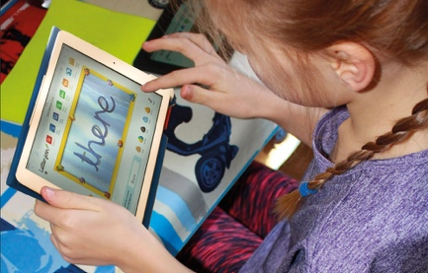
For children who experience handwriting difficulties due to fine motor development, including those who are left-handed and those with special educational needs, the appropriate additional support will be put into place. Letter-join’s Lesson Planners all include differentiation activities for extra practice/challenge.

Handwriting at Home
Pupils are encouraged to practise their handwriting at home by using the Pupil log-in for Letter-join. Teachers can set Home Learning Tasks which may include:
- Magic Patterns
- Magic Words
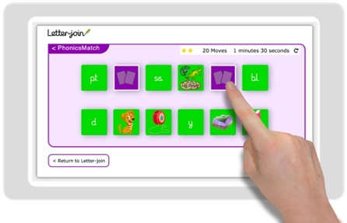
- SoundMatch
- PhonicsMatch
- LetterMatch
- LetterLotto
- Letter Families activity
- Word Search
- Word Bank
- Spelling lists
- Write it Right!
Children can also watch the word and letter animations and practice and explore other handwriting resources on Letter-join.

Key Stage Teaching
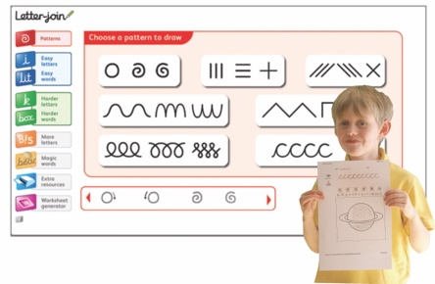
Early Years
For our youngest pupils we teach short handwriting lessons on a daily basis, which will include the following:
- enhancing gross motor skills such as air-writing, pattern-making and physical activities
- exercises to develop fine motor skills such as mark-making on paper, whiteboards, sensory trays, iPads, tablets, etc.
- becoming familiar with letter shapes, their sounds, formation and vocabulary
- correct sitting position and pencil grip for handwriting

Lesson Planners

Module 1 Print: Early Years teaches handwriting using the printed method. It starts with fine and gross motor skills warm-up exercises, correct sitting position and tripod pencil grip.
It is divided into three sections covering:
• pre-writing patterns
• easy letters and words
• harder letters and words
At the end of this module, children should be able to recognise and form all the printed, lowercase letters of the alphabet.

Key Stage 1: Years 1 and 2
Teaching progresses from five short, to three longer lessons per week:
- continuing with gross and fine motor skills exercises
- strengthening handwriting, learning and practice
- numerals, capitals and printed letters; where and when to use, learning and practice

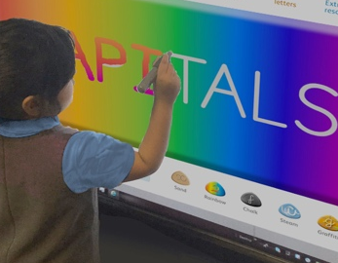
Module 2 Lesson Planners – Year 1
Module 2 Print to Cursive teaches how to correctly write capital letters, uses of printed letters, numbers, punctuation, maths symbols and other symbols. Pre-cursive patterns and cursive letters are then introduced in preparation for Module 3 when children are required to start joining their handwriting.
It is divided into three sections covering:
• warm-ups, letter families and capital letters
• uses of printed letters
• numbers and symbols
• introducing pre-cursive patterns and cursive letters
On finishing this module, children should be confident in writing all the capital and printed letters, numbers and symbols and start to become familiar with the orientation of cursive letters.
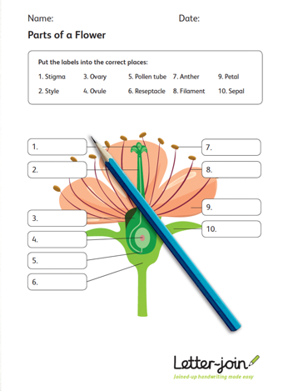
Module 3 Lesson Planners – Year 2
Module 3 – Starting Cursive introduces children to cursive letters and how to join them. They will have regular practice in letter formation and joining their handwriting.
The sections in this module cover:
- cursive letters and words
- letter families
- high frequency words
- joining techniques
- sequencing sentences
- dictation exercises
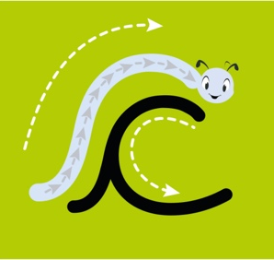
- times table facts
• GPS practice
With the regular handwriting practice throughout this module, children should now be developing the fluency and speed of their writing.

Lower Key Stage 2: Years 3 and 4
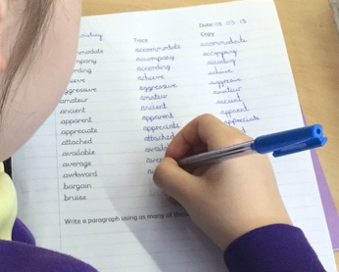
Handwriting lessons will continue two to three a week in Lower Key Stage 2.
Lesson Planner Module 4 for Year 3 is targeted at children in lower KS2 where pupils should be using a cursive style throughout their independent writing in all subjects, helping to refine their handwriting in line with the requirements of each lesson. This module covers topics such as dictation, double letters, number vocabulary, palindromes, tongue twisters, MFL (French), onomatopoeia, simile and statutory spellings.
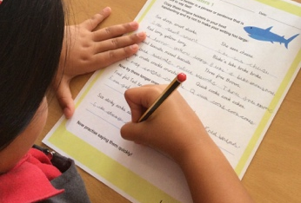
Completion of Module 4 should ensure improvement in the legibility, consistency and quality of the children’s handwriting through a variety of resources which link handwriting to other areas of the curriculum.
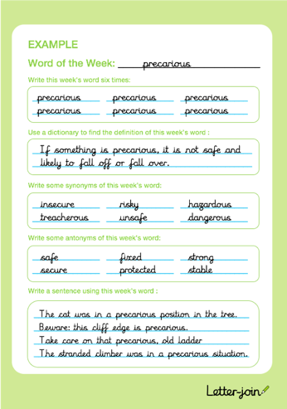
Lesson Planner Module 5 for Year 4 focuses on using handwriting practice to support other subjects in the curriculum and, at the same time, builds on fluency and consistency. This module aims to promote meaningful links with other subjects such as English, maths, science, geography and French. Making such links enables children to apply the skills they are learning in context and also provides depth to the curriculum.
Learners will continue to build on producing fluent, consistent and legible handwriting through the regular practice offered in this module’s lessons.
On concluding this module, children will have practised applying size-appropriate handwriting to all areas of the curriculum whilst maintaining fluency and legibility.

Upper Key Stage 2: Years 5 and 6
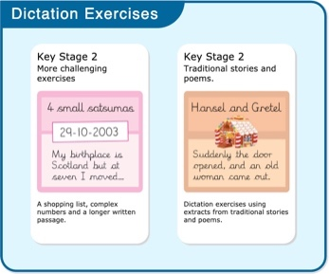
More advanced handwriting techniques will be taught during two weekly lessons:
- reinforcing cursive handwriting across the curriculum
- form-filling/labelling using printed and capital letters
- dictation exercises promoting quick note-taking and speedy handwriting writing skills
- KS2 SATs GPS practice

Lesson Planner Module 6 for Year 5 continues to build on combining fluent handwriting with other subjects across the curriculum.
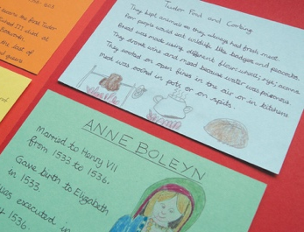
In this module, learners will have plenty of opportunity to develop the stamina and skills to write at length, with accurate spelling and punctuation. With Letter-join’s wide range of resources they will be able to work towards producing consistently neat and well-presented handwriting in all curriculum subjects.
On completing this module, children should be producing cursive writing automatically, enabling them to focus on the content of their work rather than the process of writing.

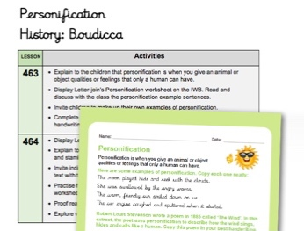
Lesson Planner Module 7 Year 6 presents learners with a range of tasks where they have to decide on an appropriate style of handwriting. Promoting speedy, fluent writing continues to be a strong feature. Challenging dictation exercises will refine pupils’ revising and checking skills as well as boosting their handwriting speed, stamina and fluency. A range of curriculum-based worksheets will give pupils the opportunity to practise writing at length.
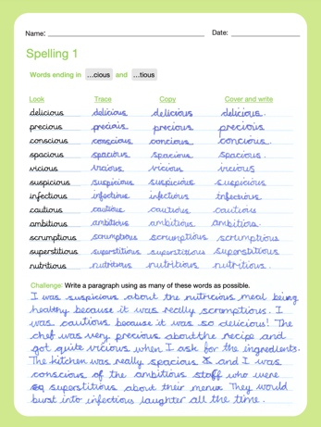
Module 7 also contains a series of worksheets to aid KS2 SATs GPS revision. They are designed to support year 6 pupils in meeting expected standards for grammar, punctuation and spellings, with lots of GPS preparation and plenty of handwriting practice.
By the end of this module, children should be able to adapt their handwriting for a range of tasks and purposes and to create different effects. They should be clear about what standard of handwriting is appropriate for a particular task, for example, quick notes, a final handwritten version, an un-joined style or capital letters. All of these writing styles are covered in this module.
Correct posture and pencil grip for handwriting
Pupils should be taught to sit correctly at a table, holding a pencil comfortably and correctly.
Sitting position
Sit with a straight back, not leaning over the page
Pull the chair close in to the table
Keep feet flat on the floor
Sit right back in the seat
The table reaches to below elbow height

Paper position for right-handed children.

Left-handed children
Left-handed children may find it difficult to follow the movements of right-handed teachers as they model letter formation (and vice versa). Teachers should demonstrate to left-handers on an individual or group basis.
- Left-handed pupils should sit to the left of a right-handed child so that they are not competing for space.
- Pupils should position the paper/book to their left side and slanted, as shown.
- Pencils should not be held too close to the point as this can interrupt pupils’ line of
vision.
- Extra practice with left-to-right exercises may be necessary before pupils write
left-to-right automatically.
Paper position for left-handed children.

The Tripod Pencil Grip
Both right and left handed children should be encouraged to use the tripod grip which allows the pen/pencil to be held securely whilst allowing controlled movements of the pen/pencil nib. We use the Tripod Grip Rhyme:
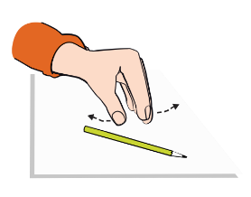
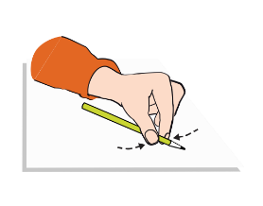
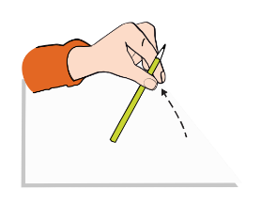
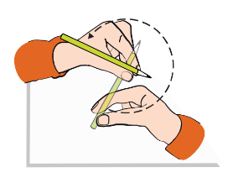
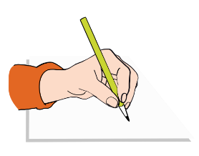
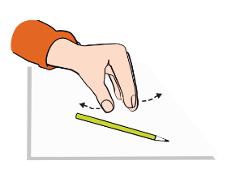
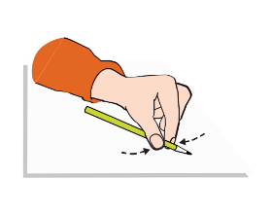
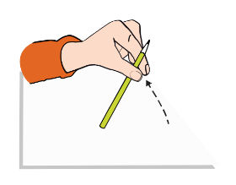
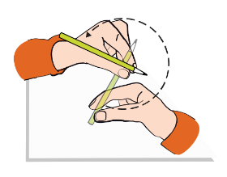
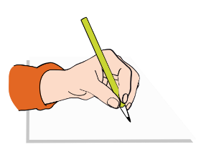
Point away the pencil, Pinch it near the tip, Lift if off the table, Spin it round... and grip.
Point away the pencil, Pinch it near the tip, Lift if off the table, Spin it round... and grip.
Right-handed pencil grip
Left-handed pencil grip

At Fulwood and Cadley, our choosen handwriting font for certain letters is below.

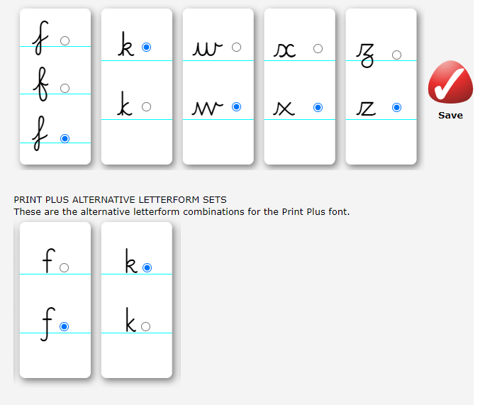

Presentation of Work

This part of the policy the importance our school places on the standard of presentation of pupils’ recorded outcomes.

This document is intended for teaching staff, non teaching staff, governors, parents, LEA representatives and OfSTED inspectors

Aims

To improve the quality of children’s work
To enhance self esteem
To give the child a sense of achievement
To give the child control over the appearance of their work
To develop organisational skills
To add to the overall ethos of the school by raising the standards and profile of presentation

School Organisation

In all subjects where written work occurs, the piece should be titled, dated and underlined from Y2 onwards. The title should be indicative of the learning objective and not merely a title of a novel or text book page.

In EYFS and Y1 the teacher may title/date the work, handwritten or printed and in Y2 during Aut term
Finished work should be ruled off within Key Stage 2.
In both key stages, pupils should write in pencil. Berol pens will be introduced as appropriate, generally when the child is fluent in their cursive writing.
To celebrate this and raise the profile of presentation, pen licenses will be used to praise the child raising self-esteem.
Felt tip pens are not to be used in exercise books

D -Date
U -Underline
M –Miss a Line
T -Title
U -Underline
M – Miss a line
S – Start

Curriculum Organisation
Maths

All work is completed in pencil
Corrections should be done at the discretion of the teacher.
When corrections are done they should be done in either green/purple pen dependent on when feedback was given – instant or distance. .

Children whether setting their work across or down the page should set down neatly, always using rulers to draw lines and placing one number in each box. .

English

Spellings should be corrected at the discretion of the teacher. Ref. English Policy

Geography, History DT and Science

All new topics should have title page to separate out the learning, knowledge organisers can be used here.
Diagrams, maps charts etc. should be done in pencil.

Children to work in exercise books that are to be passed through school. Finished books can be sent home with the child at the end of the year. A sample of books must be kept.
As in other subjects spellings are to be corrected at the discretion of the teacher.

6. Planning

It will be expected that the individual teacher will undertake the organisation of their children’s presentation as a daily on going reminder of what is expected. It may at times be necessary to take time out of a lesson to review and attend to concerns with the children.

7. Equal opportunities

All children will have the chance to develop their style of presentation in their work. Any child requiring support to do this initially or on an ongoing basis will receive support from the class teacher, the assistant teacher that are available in that class.

8. SEN

It may be necessary for some children to have either physical assistance or have some of the physicality of gluing and sticking managed for them.

9. Monitoring

HT/DHT, Senior leaders and Subject Leaders in conjunction with the Headteacher will be responsible for monitoring the work and overall presentation in their subject areas. The subject leader in agreement with the Head will give feedback to the staff and a written record will be maintained in the Monitoring File.
Any concerns will be discussed with the member of staff.
.

