Fulwood and Cadley Primary School
“Wish it, Dream it, Do it. Be Unique.”


Marking & Feedback
Policy
Sep 2025
Signed by:
 | Headteacher | Date:
 | Chair of governors | Date:

Marking and Feedback Policy

Vision Statement
Our marking and feedback policy prioritises live feedback during lessons to maximise impact and support immediate progress. By coupling live feedback with structured distance feedback and collaborative reflection, we ensure that children receive meaningful, timely input that drives learning. All work completed by the children must be attended to.

Key Principles
- Live Feedback Focus: Teachers will provide feedback primarily during lessons using pink pen, ensuring immediate intervention and support.
- Distance Feedback: After the lesson, teachers will use blue pen for additional feedback, consolidating understanding and informing next steps.
- Children Responses:
  - Children respond to teacher feedback in green pen to evidence their understanding and corrections.
  - Children use purple pen to self-edit their work, promoting independence and critical thinking.
- Collaborative Marking Quadrant: Teachers and teaching assistants will complete a marking quadrant during and after lessons to track feedback, inform planning, and ensure consistency in recognising achievements and addressing gaps.
- Clarity and Accessibility: All feedback will be clear, actionable, and designed to meet children’s’ individual needs.

Live Feedback: Rationale and Practice

Theoretical Foundation
Live feedback is grounded in research on effective formative assessment and cognitive science:
- Timely Intervention: Real-time feedback prevents misconceptions from being embedded, allowing for immediate course correction.
- Cognitive Load Management: Addressing issues as they arise avoids the compounding of errors, making the learning process more efficient.
- Engagement and Motivation: Instant feedback reinforces effort and provides clear, attainable goals for improvement.

In-Class Practice
- Teachers and teaching assistants will provide live feedback in pink pen while observing and interacting with children.
- Feedback will highlight strengths, correct errors, and set immediate next steps.
- Children respond to this feedback in green pen, demonstrating how they have addressed comments or corrected errors.

In-Class Practice
To streamline marking, a limited set of codes will be used to provide clear and effective feedback:
- VF: Verbal Feedback – This will be sufficient as the impact of the marking will be evident in the child’s response.
- SP: Spelling – Indicates a spelling error that needs to be addressed.
- S: Supported – Shows that the child received support during the task.
- RR: Rapid Recovery – Used for work that needs immediate follow-up or intervention.
- OA: Objective Achieved – Signifies that the learning objective has been successfully met.
These codes ensure efficient marking while maintaining a focus on meaningful, actionable feedback. All work completed by a child must be marked and in some cases next steps feedback provided.

Marking Quadrant
To complement live feedback, staff will collaboratively complete a marking quadrant during and after the lesson. The quadrant will include the following:
Quadrant Section | Details
Work Praised | Identifies examples of strong work, effort or successful application of learning objectives.
Needed Support | Highlights specific areas where individual or groups of children required teacher or TA support.
Presentation | Notes any issues with handwriting, layout, or general presentation of work.
Basic Errors | Records patterns of recurring errors, such as spelling, punctuation, or basic mathematical mistakes.
- Next Steps/Next Lesson Box:
  - Details actions for children who need rapid recovery on specific objectives
  - Summarises whole-class feedback themes to address at the start of the next lesson.
  - Identifies children who will need targeted support or intervention in the following session.
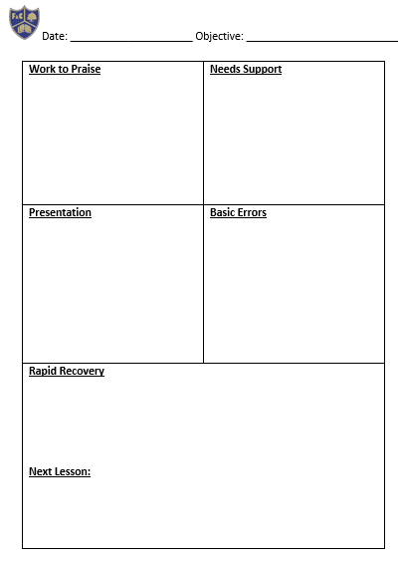
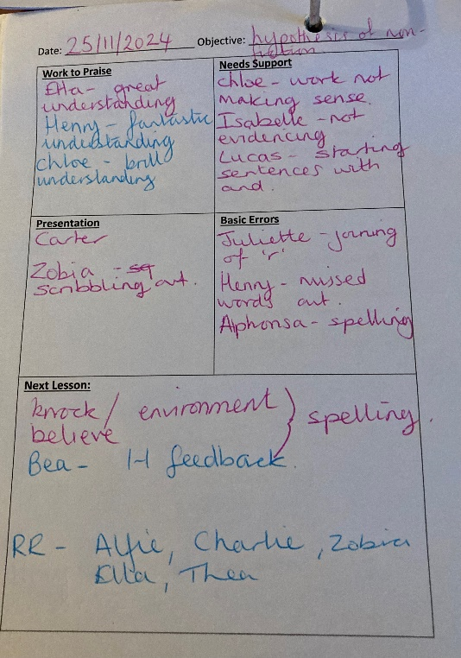
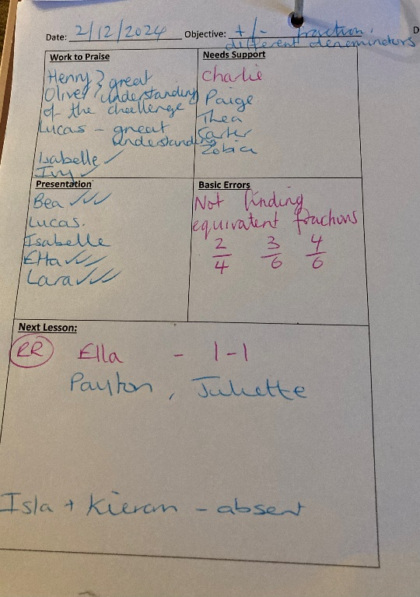
Maths Example English Example

Non-Negotiables:
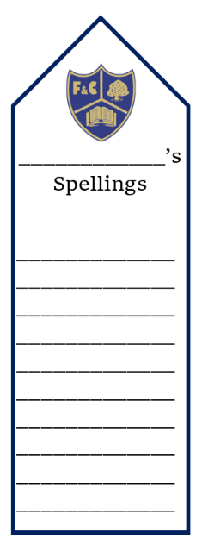
- Basic Spellings: All children are expected to spell common words correctly, particularly those they have been explicitly taught. Frequent errors in basic spellings must be attended to and addressed promptly in children’s books. Spelling errors must be indicated to the child and at the teachers discretion corrected below.
- Spelling Appropriate to Age/Level: Children should consistently apply spelling rules and patterns suitable for their age or developmental level. Mistakes beyond this scope should be corrected through targeted support and practice. The children’s spelling book marks should be used to support this process.
- Punctuation Appropriate to Age/Level: Punctuation, as expected for the child’s age or stage, must be used consistently. Errors in fundamental punctuation, such as capital letters, full stops, or commas in pupil’s work, must be highlighted and actioned to ensure progression in writing skills.
- Presentation: Poor presentation must always been addressed and improved. Children must be asked to re-do work that is not presented well.
Regular monitoring and follow-up are crucial to ensure these non-negotiables are met.

Distance Feedback: Purpose and Practice
Distance feedback in blue pen reinforces and extends live feedback by:
- Addressing trends and consolidating learning from the lesson.
- Providing deeper guidance or questions for reflection, particularly for extended tasks.
- Preparing children for future lessons by identifying key skills or knowledge gaps.

Distance Feedback: Independent Writing

Independent pieces of writing must be marked against the Expected Writing grids, with staff ticking off the relevant criteria in the margin as they assess. This marking should be done in blue pen, as it occurs after the lesson, providing a clear distinction. The grids serve as a tool for evaluating progress and identifying areas for development. Staff should use this information to inform their planning for the next unit of work. Each half term, there should be two hot writes in English, one short incidental write in English per week, and an independent write in foundation subjects each half term. These varied writing opportunities ensure consistent practice and comprehensive assessment across the curriculum.

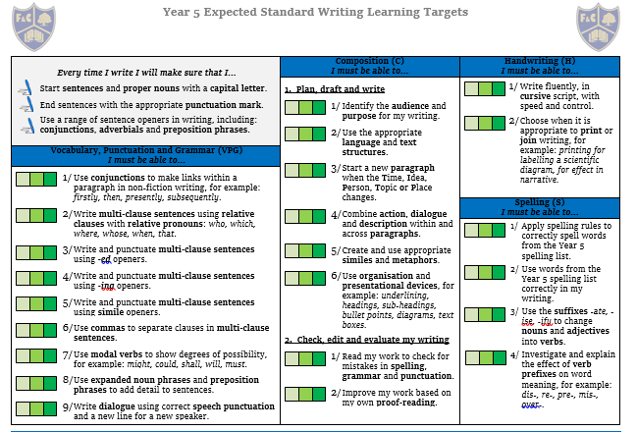

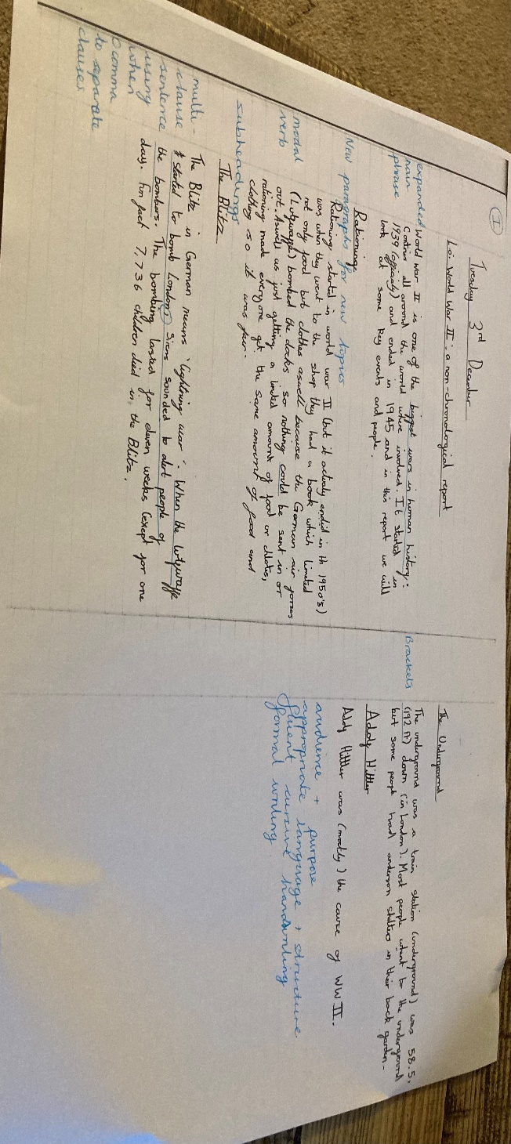

Children Engagement with Feedback
- Responding to Feedback in Green: Children use green pen to respond to teacher comments, correct errors, and extend their work.
- Self-Editing in Purple: Children use purple pen to refine and improve their work independently.
Our marking policy encourages each child to avoid using rubbers to correct mistakes, fostering a growth mind-set and promoting self-reflection. Instead, a child should place a small cross on either side of the mistake and make the correction next to it. If the correction is based on teacher feedback, the child should use a green pen, while self-assessed corrections should be completed in a purple pen. This approach ensures that learning is visible, mistakes are valued as part of the process, and progress can be easily tracked. By doing so, we emphasise the importance of ownership and accountability in the learning journey.

Feedback Workflow

KS1
- During the Lesson:
  - Teachers and TAs use pink pen for live feedback and begin completing the marking quadrant.
  - Children act immediately on feedback in edit in pencil and then towards the end of year 2 will begin to edit in purple.
- After the Lesson:
  - Teachers and TAs finalise the marking quadrant to inform planning for the next session.
  - Teachers review work in pink for additional distance feedback, focusing on deeper reflection and next steps.
- Next Lesson:

  - Teachers address whole-class feedback points from the quadrant at the start of the lesson.
  - Targeted children receive additional support based on the quadrant analysis (Rapid Recovery).
- Ongoing Self-Assessment:
  - Children consistently self-edit in pencil and then towards the end of year 2 will begin to edit in purple to build habits of critical evaluation and continuous improvement.

KS2
- During the Lesson:
  - Teachers and TAs use pink pen for live feedback and begin completing the marking quadrant.
  - Children act immediately on feedback in green pen.
- After the Lesson:
  - Teachers and TAs finalise the marking quadrant to inform planning for the next session.
  - Teachers review work in blue pen for additional distance feedback, focusing on deeper reflection and next steps.
- Next Lesson:
  - Teachers address whole-class feedback points from the quadrant at the start of the lesson.
  - Targeted children receive additional support based on the quadrant analysis.
- Ongoing Self-Assessment:
  - Children consistently self-edit in purple pen to build habits of critical evaluation and continuous improvement.

Monitoring and Review
The effectiveness of this policy will be regularly reviewed through:
- Lesson observations and monitoring of live feedback practices.
- Sampling of marking quadrants and student books for quality and consistency.
- Feedback from staff and children to ensure the approach is supporting progress effectively.
This policy ensures a structured, research-driven approach to marking and feedback, embedding a cycle of improvement and reflection that supports all learners.

Staff Workload
Prioritising live feedback significantly reduces staff workload by minimising the need for extensive marking outside of lesson time. As feedback is delivered in real time, teachers address misconceptions and provide next steps directly, eliminating the backlog of unmarked work and lengthy written comments after lessons.
The collaborative use of the marking quadrant with teaching assistants further streamlines the process, ensuring observations and feedback are recorded efficiently during the lesson.
This approach not only saves time but also ensures that feedback is more immediate and impactful. By shifting the focus to live, in-lesson marking, teachers can dedicate more time to planning high-quality lessons and engaging with children, rather than spending hours on after-school marking.

