Fulwood and Cadley Primary School



Teaching and Learning Policy
Wish it. Dream it. Do it. Be Unique.

Contents
1. Introduction and Purpose
2. School Vision and Values
3. Aims of the Policy
4. Principles of Effective Teaching and Learning
5. Adaptive Teaching
6. Curriculum Delivery
7. Lesson Structure (R.U.A.C.E Framework)
8. Subject-specific Approaches
9. Active Learning Strategies
10. Assessment and Feedback
11. Learning Environment
12. Inclusion and Equal Opportunities
13. Developing Metacognition and Self-Regulation Across School
14. Roles and Responsibilities
15. Monitoring and Review

1. Introduction and Purpose
This policy sets out Fulwood and Cadley Primary School’s approach to delivering high-quality teaching and learning. It provides clarity and consistency for staff, pupils, parents and governors. The policy aligns with the school’s mission to nurture diversity, resilience and aspiration while preparing pupils with the skills, knowledge and character to thrive in life.

2. School Vision and Values
At Fulwood and Cadley, our pupils are confident, ambitious and independent learners who show resilience and perseverance. They are well-mannered, empathetic, courageous and proud of who they are. Our vision is underpinned by British and school values: courage, respect, aspiration, resilience, imagination, determination, democracy, the rule of law, mutual respect, tolerance of different faiths and beliefs, and individual liberty.

3. Aims of the Policy
The aims of this Teaching and Learning Policy are to:
• Promote consistently high-quality teaching across the school.
• Ensure that learning is defined as a change to long-term memory, in line with research (Kirschner, Sweller & Clarke, 2006).
• Support inclusive practice, adaptive teaching and equality of opportunity.
• Embed resilience, aspiration and kindness in every child’s learning journey.
• Provide clarity on lesson structures, assessment and active learning strategies.

4. Principles of Effective Teaching and Learning
Effective teaching and learning at Fulwood and Cadley is underpinned by:
• High expectations of all learners.
• A safe, inclusive and purposeful environment.
• Clear objectives and success criteria.
• Teaching that builds on prior knowledge and promotes sticky learning.
• Adaptive teaching that ensures all pupils can access the curriculum.
• A balance of substantive and disciplinary knowledge.
• Use of retrieval practice, modelling, scaffolding and metacognition.

5. Adaptive Teaching
Adaptive teaching is a central feature of our approach. Unlike fixed differentiation, adaptive teaching requires teachers to respond in real time to pupils’ needs, adjusting explanations, resources, scaffolds and questioning to ensure all learners are supported and challenged. The approach is informed by:
• Cognitive Load Theory (Sweller, 1988) – ensuring content is presented in manageable steps.
• Rosenshine’s Principles of Instruction – regular review, modelling, guided practice and checks for understanding.
• Evidence-informed pedagogy – live feedback, scaffolding and graduated removal of support.
Adaptive teaching strategies include flexible grouping, targeted questioning, scaffolded tasks, manipulatives, visual supports and enrichment activities for greater depth. This ensures equity of access and high outcomes for all pupils.

6. Curriculum Delivery
Our curriculum is planned on a two-year cycle, ensuring consistency and breadth of learning experiences from EYFS to Year 6. Pupils develop both substantive knowledge (facts, concepts) and disciplinary knowledge (skills, methods). Learning is designed to be memorable and cumulative, with opportunities for cross-curricular links.

7. Lesson Structure (R.U.A.C.E Framework)
All lessons follow a consistent structure informed by research on metacognition and retrieval:
• Remember – Retrieval activities to recall prior knowledge.
• Understand – Explicit instruction and effective questioning.
• Apply – Independent practice to consolidate skills.
• Create – Real-life application of knowledge.
• Evaluate – Reflection, feedback and metacognition.

8. Subject-specific Approaches
Teaching and learning are shaped by subject pedagogy:
• English – Immersion in texts, grammar focus, modelled and independent writing, weekly short writes, clear working walls, and explicit grammar teaching.
• Mathematics – Daily fluency, problem solving with stem sentences, structured teaching, independent practice and application of skills.
• Phonics – Revisit, teach, practise, apply model with constant live feedback, use of GPCs, tricky words and phonics games.
• Foundation subjects – Focus on building disciplinary and substantive knowledge through enquiry, retrieval practice and cross-curricular connections.
What does teaching and learning look like at Fulwood and Cadley?
Phonics

Revisit/Review  Select specific GPCs, decodable, Tricky and HF words to review. | Revisit phonemes from the beginning of the phase and tricky work – (flashcards).  Revisit a specific sound including previous tricky words (based on gap analysis). This can be done through flash card, through a game or my turn, own turn, your turn. |  | Constant live feedback and circulating the room, checking on understanding. Display everything from the lesson and ensure the children know that it is there. It is ok for them to copy. It is better than them getting it wrong and the mistake becoming embedded – look at the working wall but don’t look at the working wall. Always use letter names when spelling model in print (as books are not written in cursive).
Explicit Teach  Use sound buttons for blending and phoneme frames for segmenting. | Use sound buttons for blending and phoneme frames for segmenting. Teach the new sound and tricky word. When introducing tricky words, ensure children understand which part(s) of the word are tricky.  Model new learning by sounding out words that children can see and allow them to blend them together. Segment words for the children to spell and ensure these examples are on display.
Practise  select appropriate words for reading and writing | Practice the new learning and the new tricky work. See appendix in Red Rose Letters and sounds for practice ideas. Ensure that, when a game is played, it isn’t dominating the whole lesson. Games should be quick and snappy.
Apply  include newly taught GPCs and Tricky/HF words combined with previous learning. | Apply new learning into a sentence. This can be read, written or both. Ensure the sentence is on the board too.
Assessment | Use my turn, our turn, your turn (individuals) focusing on target children.  Use ongoing assessment to identify misconceptions quickly (e.g., mini whiteboard checks, quick oral responses or exit tickets). Provide immediate feedback and address errors before moving on.  Make explicit links between phonics sessions and wider literacy activities. Encourage children to apply their phonics knowledge in guided reading, independent writing and across the curriculum to allow for further assessment.  Model activities before allowing the children to complete.  Keep those children who are not secure on the carpet for further input.
Adaptations | Adapt activities to meet the needs of all learners. Provide pre-teaching or additional scaffolding for children who are less confident, while offering challenge (e.g., extending sentences, applying phonics in longer writing) for more confident learners.  Use sound buttons, talking tins, mixed ability pairs, challenge and stretch vocabulary.
Revisit/Review  Select specific GPCs, decodable, Tricky and HF words to review. |  | Revisit a specific sound including previous tricky words. This can be done through flash cards and through a game. |  | Constant live feedback and circulation the room, checking on understand. Display everything and ensure the children know that it is there. It is ok for them to copy. It is better than them getting it wrong and the mistake becoming embedded – look at the working wall but don’t look at the working wall. Always use letter names when spelling.
Teach  Use sound buttons for blending and phoneme frames for segmenting. |  | Use sound buttons for blending and phoneme frames for segmenting. Teach the new sound and tricky word. When introducing tricky words, ensure children understand which part(s) of the word are tricky.  Model new learning by sounding out words that children can see and allow them to blend them together. Segment words for the children to spell and ensure these examples are on display.
Practise  select appropriate words for reading and writing |  | Practice the new learning and the new tricky work through a game. See appendix in Red Rose Letters and sounds.
Apply  include newly taught GPCs and Tricky/HF words combined with previous learning. |  | Apply new learning into a sentence. This can be read, written or both. Ensure the sentence is on the board too.
Assessment |  | Use ongoing assessment to identify misconceptions quickly (e.g., mini whiteboard checks, quick oral responses or exit tickets). Provide immediate feedback and address errors before moving on.  Make explicit links between phonics sessions and wider literacy activities. Encourage children to apply their phonics knowledge in guided reading, independent writing and across the curriculum to allow for further assessment.
Adaptations |  | Adapt activities to meet the needs of all learners. Provide pre-teaching or additional scaffolding for children who are less confident, while offering challenge (e.g., extending sentences, applying phonics in longer writing) for more confident learners.  Use sound buttons, talking tins, mixed ability pairs, challenge and stretch vocabulary.

What does teaching and learning look like at Fulwood and Cadley?
English
In a unit there should be: | Staff to use their professional judgement to use the wealth of resources that we already have to support in the planning of each phase.  Misconceptions and basic errors must be addressed.
Immerse the children into a text - 1 or 2 days
A reading week (may be less than a week if looking at non-fiction) using the same text.
Grammar focus 1
Gathering content – teach skills needed for that text type
Grammar focus 2
Outcome 1- Modelled write – modelling success criteria and model misconceptions based on previous day’s writing.
No Grammar focus as grammar is being modelled through modelled write.
Outcome 2 - Independent write – based on class model
Grammar focus 3

Working walls to have the following headings:
Grammar focus 1, grammar focus 2, grammar focus 3, reading, gathering content and writing.
This will help the children to see how reading flows into writing and will give them support and guidance into each phase.
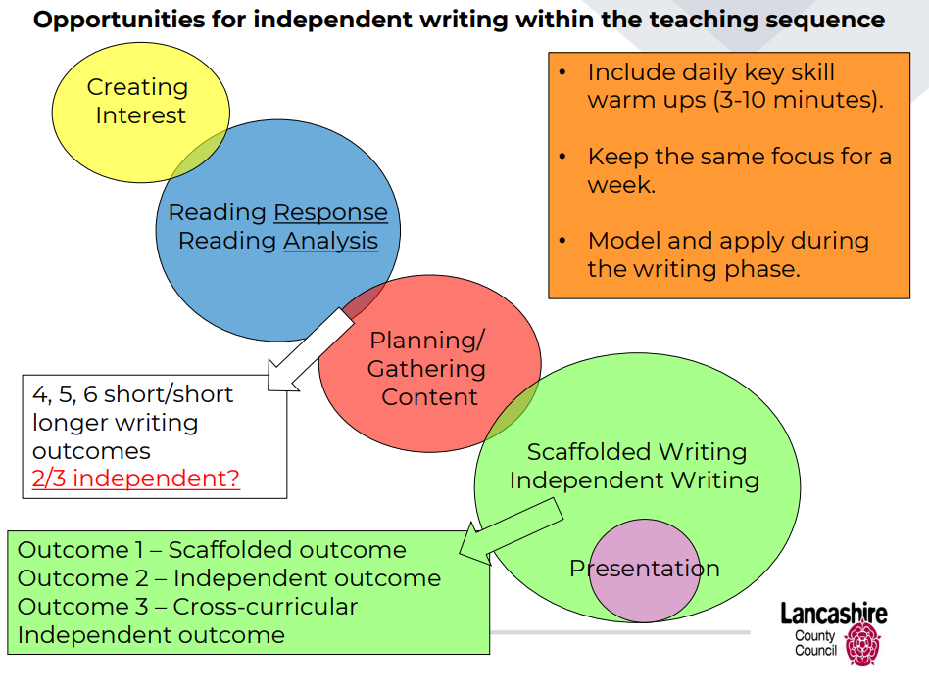
Weekly

Weekly ensure the children are doing an independent short write – even in the reading week. For example: the reading focus may be to infer a character’s feelings. You may model a diary entry pulling out evidence from the text. The children would have a go using your model. The next day, the children will have the same objective with the word independently and they would apply their skills to write a diary entry based on another character in the book.
One grammar focus per week.
One spelling rule per week.
Daily
Grammar | One grammar skill per week – pre-set based on gaps and the end of unit outcome.  Monday – oral grammar (i.e. focus is relative clauses, children will practice reading out-loud sentences with relative clause with teaching explaining relative clauses).  Tuesday – oral grammar like Tuesday.  Wednesday – Part of the grammar given - innovation (i.e. The man_________ is playing football). Written on white boards/in books and orally said too.  Thursday – repeat Wednesday with less detail (i.e. the man…)  Friday grammar in books that is independent that shows the weeks learning. Give the children a stimulus.  Working wall to reflect all the grammar taught in a unit – it builds up over the unit and can then be used as a success criteria.  Green pen used for any corrections. | Live feedback and marking throughout the whole lesson.
Teach | Teach the new objective.  Model handwriting, spelling and grammar. | Live feedback and marking throughout the whole lesson.
Apply new skill independently | Every child, every lesson should have the opportunity to work independently to apply the new learning.  Green pen used for any corrections. | Live feedback and marking throughout the whole lesson.

What does teaching and learning look like at Fulwood and Cadley?
Maths

Maths Key Skills | Fluency daily on an area of arithmetic (topic to change weekly).  In books.  Friday test based on the topic – to be recorded on the monitoring spread sheet.  Green pen used for any corrections. | Live feedback and marking throughout the whole lesson. Staff to use their professional judgement to use the wealth of resources that we already have to support in the planning of their maths lessons.
Explore | Explore a problem together.  Use stem sentences to allow the children to verbalise their reasoning
Teach | Teach the new objective with variation  Maths resources out every lesson.  Additional fluency questions when needed in a variety of different ways.  Update working well with examples, stem sentences and key vocabulary.
Practice | All the children to practice the new skill on their whiteboards.  Further input for those who need it.  Those who are fluent to move on to working independently.
Apply new skill independently | Every child, every lesson should have the opportunity to work independently to apply the new learning.  Green pen used for any corrections.

9. Active Learning Strategies
At Fulwood and Cadley we want all children to be flexible, creative and proactive – young people who can solve problems, make decisions, think critically, communicate ideas effectively and work efficiently within teams and groups. This document is not intended to be a definitive resource but one which provides practical advice for teachers of Fulwood and Cadley on a varied range of methods which they may wish to integrate into their daily learning and teaching activities. It is hoped that teachers will find it a helpful tool in planning and creating a stimulating, enriching, challenging and focused environment for both their pupils and themselves.
For all of this to happen effectively, each strategy will need to be modelled explicitly initially so that the students ate fully aware of what is expected of them during each part of the tool kit.
Active Learning strategies that can be used in all subjects.
Talk Partners
Using 'talk partners' in a lesson, means a teacher asks a question and then asks the class to discuss their answer to this question with a partner,
Think, Pair and Share
Think-pair-share is a collaborative learning strategy where students work together to solve a problem or answer a question. requires students to (1) think individually about a topic or answer to a question; and (2) share ideas with classmates.
Ping Pong
Ping Pong is a cooperative learning strategy that has students working in pairs to engage in processing new content or to practice a new skill.
Ping Pong works like this:
- The teacher poses a question, problem, or task to which there are many possible responses.
- Students are paired up and each pair has one “paper” for recording answers and two pens or pencils. Examples of possible “papers” include: a worksheet, a map, a blank sheet of paper, a graphic organiser, or whatever the lesson requires.
- In pairs, students are designated A or B.
- Student A records an answer on the paper, while Student B is responsible for checking the answer.
- Student A then passes the paper to Student B, who records an answer. Student A is now responsible for checking Student B’s response.
- Students continue taking turns recording and checking answers by passing the paper back and forth (as in the game of Ping Pong).
This approach can also work as a teacher student pair. Model a concept, let them have a go and then continue the process.
Think it, Say it, Write it
Give the students to opportunity to think about the question posed. Then allow the children to say it (multiple times if needed) and then allow them to write it.

Bingo
Generate a question grid, show all the answers of the board. Students to select up to 6 answers. Then go through the questions with the students and get them to circle the answer if they have got it. If they have all 6 answers, they shout bingo.
Show me
Pose a question, all the student would then show their answer on a whiteboard. Select one student to share. By doing it this way, every child has then had to opportunity to contribute. This also allows assessment to take place immediately.
Role Play
Allowing the students to role play will help to show their understanding of a concept. Students could act out the meaning of words, their understanding if a story or of a concept in science. The students could also act out what is happening in a maths equation – for example physically jumping on a number line.
Fastest Finger
Give the students a table of possible answers. Read a question, in pairs the children race to put their finger on the answer. This can also be done in phonics.

10. Assessment and Feedback
Assessment is integral to learning. Teachers:
• Use formative assessment daily to inform planning.
• Provide live feedback in lessons (pink pen), distance feedback (blue pen) and encourage pupil responses (green and purple pens).
• Use marking quadrants to identify strengths, support needs and next steps.
• Track progress systematically and ensure interventions are timely.

11. Learning Environment
The learning environment is calm, purposeful and stimulating. Displays celebrate pupils’ work, reinforce key concepts and reflect our values. Resources are accessible and promote independence. Classrooms are inclusive, safe spaces where every child is encouraged to contribute and succeed.
Our learning environment promotes independence, organisation and self regulation. Working walls, visual scaffolds, vocabulary prompts and models of excellence support pupils to monitor and direct their learning.
Calm, predictable routines reduce cognitive load and support emotional regulation for all pupils including those with SEND.

Fulwood and Cadley’s Working Wall Exemplars
Maths
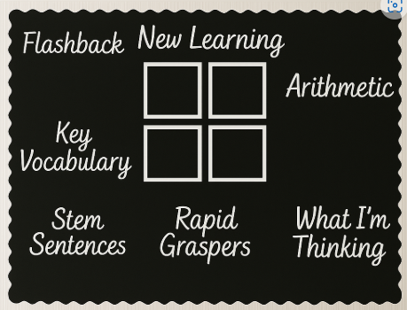
English
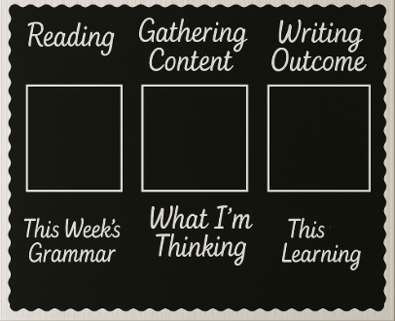
Phonics
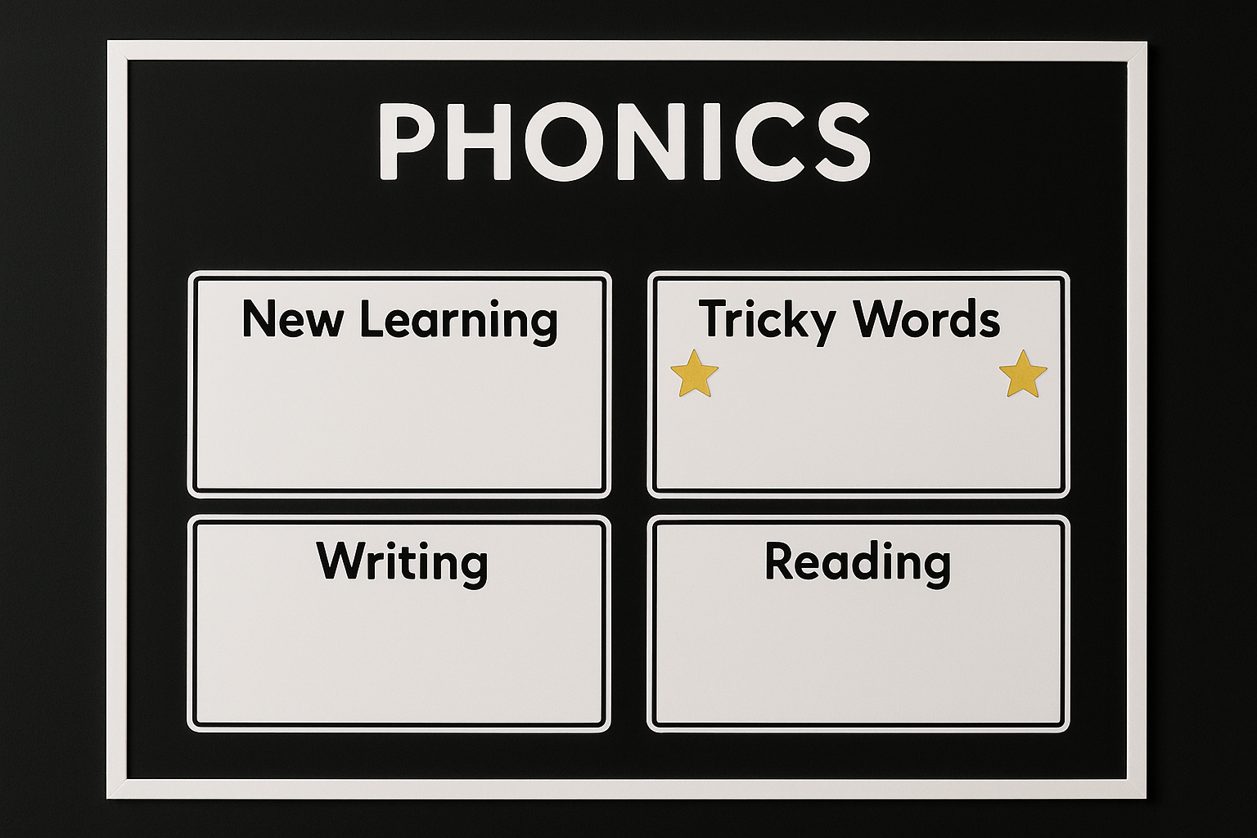

12. Inclusion and Equal Opportunities
We are committed to equity, diversity and inclusion. Adaptive teaching, reasonable adjustments and targeted interventions ensure that pupils with SEND, EAL and those from disadvantaged backgrounds can thrive. The school actively promotes the protected characteristics under the Equality Act 2010.
IDENTIFYING SPECIAL EDUCATIONAL NEEDS
The identification of SEN is built into the overall approach to monitoring the progress and development of all pupils through the school’s Policy on Teaching and Learning;
It is really important that the school identifies pupils who experience difficulties accessing learning and general school life opportunities early. This is achieved through continual use of classroom observations and assessments of all pupils and is known as ‘The Graduated Approach’. Progress is tracked on a termly basis and where appropriate, more frequently than this. The SENCo liaises closely with the assessment co-ordinator to analyse data and individually track pupils who are experiencing difficulties.
Class teachers discuss any concerns with the SENCo and Assessment Coordinator. If further action is deemed necessary, the parents are informed immediately. All criteria for defining Special Educational Needs are in accordance with Lancashire Education Authority policy. The key principles and details are laid out in detail in the Special Educational Needs Information Report.

THE GRADUATED APPROACH TO SEN SUPPORT: Assess - Plan - Do - Review
 | What | Who | How
ASSESS | Initial Concern | Parents / School | Professional Dialogue, Discussions with Parents, Learning Walks  Pupil Progress Meetings
ASSESS | Classroom adaptations and/or targeted support in class | Class teacher  Teaching Assistants | Examples may include:  Classroom Positioning  Organisations Aids (Task Ladder etc)  Coloured Overlays  Focus Group with CT/TA
ASSESS | Targeted and time-limited small group interventions | Teaching Assistants under the direction of the Class Teacher | Usually in withdrawal for limited periods  Extra Provision is Recorded – this is known as ‘Provision Mapping’
ASSESS | Further information gathered | Parents / pupil / colleagues / SENCo | Professional Dialogue  Discussions with Parents
ASSESS | Possible further adaptations and/or additional targeted support in class | Class teacher  Teaching Assistants  SENCo / Inclusion Lead
ASSESS | Observation and or additional assessments | SENCo | Examples may include:  YARC and/or WRIT, BPVS etc

This process is followed to ensure that any another reason for slower than expected progress has been thoroughly investigated.

 | What | Who | Notes
PLAN | Parents informed of intention to make additional provision | Class Teacher | Meeting if possible  Telephone call
PLAN | Pupil added to SEN register | SENCo
PLAN | SEN Pupil Profile created | Class teacher / Parents / SENCo / Pupil | This is an overview of a pupil’s additional needs
PLAN | Individual Education Plan (IEP) written (usually*) with 1, 2 or 3 Specific, Measurable, Attainable, Realistic, Timed (SMART) targets OR Personalised Provision Plan (PPP) for higher needs children | Class teacher with support from SENCo. | Parents are involved throughout the IEP/PPP process. They are encouraged to help pupils to meet their targets and are kept informed when targets are met and/or adjusted.
* For some children with additional needs, an IEP may not be necessary.

 | What | Who | When
DO | 1:1 teaching towards IEP targets or Delivery of Personalise Curriculum through PPP | IEPs delivered by TA, supervised by Class Teacher. PPP – all staff | Little and often, as specified on the IEP or PPP delivered throughout the day
DO | Progress towards IEP targets monitored | TA, supervised by Class Teacher. Pupils are involved in this process | Weekly
DO | Revision of IEP targets  Revision of PPP | Class Teacher | As and when necessary (when targets met or adjusted)
DO | Teachers and/or Teaching Assistants access Continuing Professional Development courses to enhance their understanding of a specific difficulty relating to a child in their class | Class Teachers (Need identified by CT, SENCo and/or Senior Leadership) | When appropriate

 | What | Who | Notes
REVIEW | Full review of IEP 4 times per year (See below)  PPP reviewed on a regular basis, as agreed at time of writing. | Class teacher (informed by weekly monitoring) | Evaluations of IEPs sent home to parents.  Evaluation of PPP shared with parents
REVIEW | SEN Pupil Profile updated annually | Class teacher / Parents / SENCo / Pupil | Significant changes mid-year will also result in an update.

SEND Provision
Provision for pupils with SEND is guided by the EEF’s five recommendations.

1. Create a positive and supportive environment for all pupils
• High expectations for all
• Positive relationships and a focus on wellbeing
• Proactive behaviour support

2. Build an ongoing, holistic understanding of pupils and their needs
• Use the graduated approach (assess, plan, do, review)
• Involve families, pupils and specialists
• Focus on individual barriers, not labels

3. Ensure access to high quality teaching
• Adaptive teaching strategies that support, not replace, classroom learning
• Scaffolding, explicit instruction and modelling
• Opportunities for metacognitive development

4. Complement high quality teaching with interventions
• Carefully chosen, evidence-based interventions
• Clear links between intervention and class learning
• Close monitoring and regular review

5. Work effectively with teaching assistants
• Deployment that supports pupil independence
• Pre-teaching, scaffolding and structured intervention delivery
• Clear communication and shared planning
At all stages, teachers support pupils with SEND to develop metacognitive strategies, including how to plan, monitor and evaluate their learning.

13. Developing Metacognition and Self-Regulation Across the School
Metacognition is woven into teaching across all subjects. Teachers:
• Model their own thinking aloud
• Teach pupils how to plan, monitor and evaluate tasks
• Use prompts to support pupils’ strategic choices
• Provide structured opportunities for reflection
• Withdraw scaffolds gradually to promote independence
Pupils learn to:
• Recognise their strengths and areas for development
• Select effective strategies for tasks
• Monitor their understanding
• Make changes when needed
• Evaluate learning processes, not just outcomes

14. Roles and Responsibilities
• Governors – Monitor and hold leaders accountable for the quality of education.
• Headteacher and SLT – Lead, monitor and support high standards of teaching and learning.
• Subject Leaders – Drive curriculum design and monitor subject quality.
• Teachers – Plan, deliver and assess high-quality learning.
• Pupils – Engage actively, respect others and take responsibility for their learning.
• Parents – Support learning at home and work in partnership with school.

15. Monitoring and Review
The implementation of this policy will be monitored through observations, book scrutiny, learning walks, data analysis and pupil voice. The policy will be reviewed annually by the Senior Leadership Team and Governors.

