 | Autumn Term 2025 |  | Spring Term 2026 |  | Summer Term 2026
 | Autumn A  All about me/  Autumn  8 weeks | Autumn B  Celebrations  7 weeks | Spring A  Space/ Winter  6 weeks | Spring B  People who help us.  5 weeks | Summer A  Summer/Growth /Animals  5weeks 4 days | Summer B  Summer/Oh I do like to be Beside the Seaside  7 weeks
Enrichment: event, visitor, author, poet | National Poetry Day  3rd October 2025 | Halloween 31st October  Bonfire Night  5th November 2025  Christmas |  | World Book Day  Visit to the Post Office/post box | School trip linked to animals
English  Core text | Weeks 1 and 2: Stories about starting school and children’s choice of stories  Weeks 3 and 4  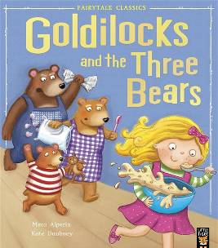  Weeks 5 and 6  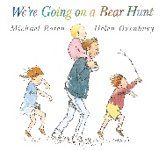  Weeks 7 and 8  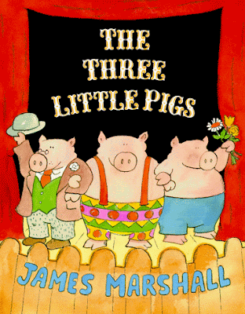 | Week 9 and 10  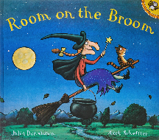  Weeks 11 and 12  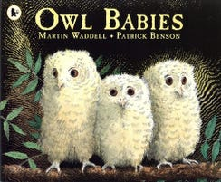  Weeks 13, 14 and 15  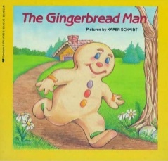 | Weeks 1 and 2  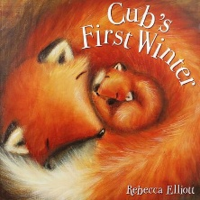  Weeks 3 and 4  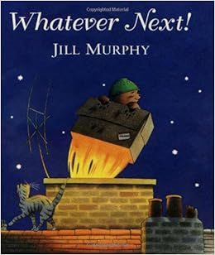  Weeks 5 and 6  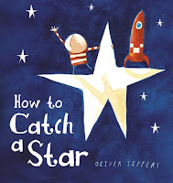 | Weeks 7 and 8  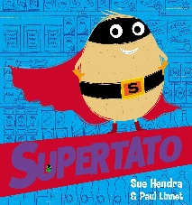  Weeks 9 and 10  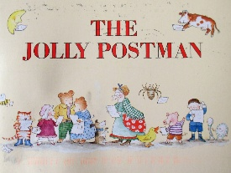  Week 11  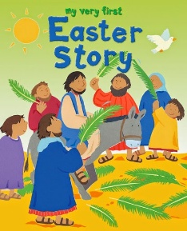 | Weeks 1 and 2  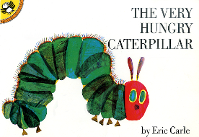  Week 3 and 4  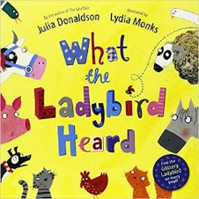  Weeks 5 and 6  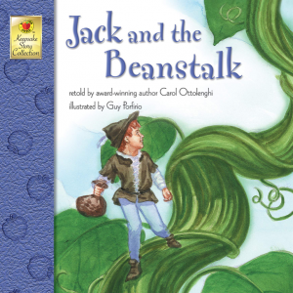 | Weeks 1, 2 and 3  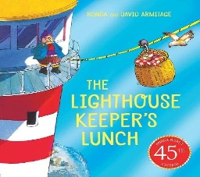  Weeks 4, 5 and 6  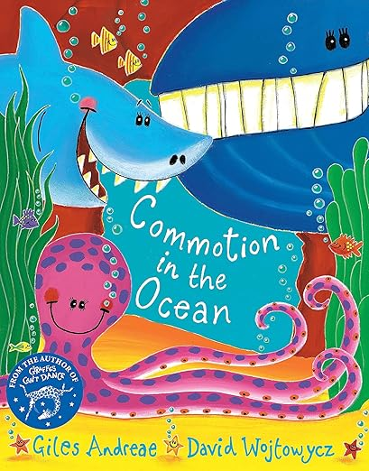
Other Stories | Peace at Last  The Gruffalo  The Colour Monster  The Worry Monster | Diwali Story  Pumpkin Soup  Daisy’s Dragon  The enormous Turnip  Information books on celebrations | Percy park keeper  One Snowy Night | Supertato books  Information books on people who help us and winter | Eric Carlisle Stories  Rosie’s Walk  Farmer Duck | Octopus: Shocktopus  The Fish who could Wish  Rainbow Fish  The Lighthouse keepers books
Nursery rhymes/songs | 1 2 3 4 5 once I caught a fish alive  5 currant buns  Pat a cake  5 little ducks  Dingle Dangle Scarecrow  This old man | Im a little tea pot  The grand old duke of York.  Ring a ring of roses  Hickory Dickory Dock | Twinkle, twinkle little star  Wind the bobbin up  Happy and you know it  Rock a bye baby  Five little monkeys  Head shoulders knee and toes. | Old MacDonald  Wheels on the bus  Incy wincey spider  Row row row your boat  Miss Polly had a Dolly  Humpty Dumpty | Baa baa balck sheep  Old Macdonald (revisit)  10 in a bed  10 fat sausages  5 little speckled frogs | Revisit all nursery rhymes.
Phonics  Red Rose Letters and Sounds | Phase 2:  Week 1: s a t  Week 2: p i n  Week 3: m d g  Week 4:  Consolidate s a t p I n m g g  Week 5: o c k – the  Week 6: ck e u – I to  Week 7: r h b- no go  Week 8: consolidate o c k ck e u r h b - into  Assessment week | Phase 2  Week 9: f ff l –the I to no go into  Week 10: ll ss -  the I to no go into  Week 11: Consolidate f ff l ll ss- the I to no go into  Phase 3  Week 1: j v w-he she  Week 2: x y z /zz we be me  Week 3: qu ch sh was my  Week: consolidate assessment week | Phase 3  Week 4: th/th ng-you they  Week 5: ai ee-her all  Week 6: igh oa with two syllable words-are like(Phase 4)  Week 7: oo/oo with two syllable words-said when (phase 4)  Week 8: ar or with two syllable words-have one (phase 4)  Week: consolidate and assessment week | Phase 3  Week 9: or ow-come do (phase 4)  Week 10: oi ear( including pseudo words)-so were (phase 4)  Week 11: air ure er (including pseudo words)- out what little (phase 4)  Week 12: Consolidation and assessment week  Week: 13: Consolidation and assessment week | Phase 4  Week 1: CCVC &CCVCC- said so have like  Week 2: CCCVC & CCCVCC- come some were there  Week 3: Polysyllabic words containing Phase 2 and 3 graphemes with  adjacent consonants.  - little do one when  Week 4: Polysyllabic words containing Phase 2 and 3 graphemes with  adjacent consonants.  - out what its  Week 5 consolidation and assessment | Rpt phase 4  Week 1: CCVC &CCVCC- said so have like  Week 2: CCCVC & CCCVCC- come some were there  Week 3: Polysyllabic words containing Phase 2 and 3 graphemes with  adjacent consonants.  - little do one when  Week 4: Polysyllabic words containing Phase 2 and 3 graphemes with  adjacent consonants.  - out what its  Week 5 consolidation and assessment
Writing  By the end of term  Vocabulary  - First name  - Surname  - Alphabet  - lowercase letter  - capital letter  - finger space  - caption  - sentence  - full stop  - story  - beginning middle end  - phoneme grapheme/letter(s) spelling for the sound  - digraph  - trigraph  - segment  - blend  - syllable  - tricky  - words  - Question mark  - Exclamation mark | Handwriting  • Form recognisable letters (Phase 2) with the correct orientation.  • Begin to use a tripod grasp.  Composition  • Write their first name correctly.  • Use some identifiable letters (Phase 2) to communicate meaning and use them to write words, captions, sentences and labels. Spelling • Spell words by identifying the sounds and then writing the sound with letter/s (Phase 2). • Segment and blend the sounds in simple words and name sounds (Phase 2).  • Spell ‘Tricky Words’ from Phase 2 mostly correctly.  Grammar and Punctuation  • Recognise a capital letter at the start of a name and a sentence |  | Handwriting  • Form recognisable letters (Phase 2 and Phase 3) with the correct orientation.  • Begin to use cursive lead-in lines (if appropriate from Phase 3 onwards).  • Sit on a chair with a straight back and my feet on the floor.  • Control finer tools when playing with dough.  • Use a tripod grasp with control.  • Form lower-case and capital letters correctly. Composition  • Write their first name correctly with a capital letter.  • Use mostly correctly formed letters (Phase 2 and Phase 3) to communicate meaning and use them to write words, captions, sentences and labels.  • Begin to rehearse what to write orally before writing.  • Begin to independently write short sentences with words with known sound-letter correspondences using a capital letter and full stop mostly correctly (Phase 2 and Phase 3).  • Begin to sequence sentences in a story.  • Read back their writing.  • Re-read what they have written to check that it makes sense.  Spelling  • Spell words by identifying the sounds and then writing the sound with letter/s (Phase 2 and Phase 3).  Segment and blend the sounds in simple words and name sounds (Phase 2 and Phase 3).  • Spell ‘Tricky Words’ from Phase 2 and Phase 3 mostly correctly.  Grammar and Punctuation  • Mostly use full stops and capital letters in the correct places. |  | Name and write the letters of the alphabet (lowercase and capital letters).  • Consistently sit letters on the lines, using ‘Letter Join’ formations. Children will be encouraged to use lead-in lines from Phase 3 onwards if appropriate.  • Consistently use a capital letter for all names and at the start of each sentence.  • Consistently use a full stop at the end of each sentence.  • Use finger spaces, when writing sentences.  • Independently hold and write at least a 4-word sentence.  • Independently write and sequence 3 related sentences.  • Recognise the simple genre features of a narrative (beginning, middle and end).  ELG:  Writing Children at the expected level of development will:  - Write recognisable letters, most of which are correctly formed;  - Spell words by identifying sounds in them and representing the sounds with a letter or letters;  - Write simple phrases and sentences that can be read by others.  Write their surname correctly with a capital letter.
Reading  By the end of the term  Vocabulary  - Initial: sound/  sound at the start  - segment  - blend  - phoneme  - grapheme/letter(s) spelling for the sound  - digraph  - trigraph  - adjacent consonant  - syllable  - tricky words  - nonsense words  - alphabet  - title  - blurb  - picture  - author  - illustrator  - caption  - sentence  - story  - beginning  - middle  - end  - character  - retrieve (find)  - predict  - sequence (first, next, then, finally)  - infer (feelings)  - fiction  - non-fiction | Word Reading  • Join in with rhymes and stories.  • Join in with the rhythm of well-known rhymes and songs.  • Identify sounds in words, in particular, initial sounds (Phase 2).  • Segment and blend simple words demonstrating knowledge of sounds (Phase 2).  • Segment and blend simple words to read a caption/sentence (Phase 2).  • Link sounds to letters in the alphabet (Phase 2). • Read a few common exception words matched to Red Rose letters and Sounds(Phase 2 Tricky Words).  Comprehension  • Hold a book, turn the pages and indicate an understanding of pictures and print.  • Know the names of different parts of a book e.g. title, blurb, author and illustrator.  • Talk about events and remember details about the characters in books from stories they have heard (retrieve).  • Make suggestions about what might happen next in a story (predict).  • Tell a story to friends.  Rhino Readers and corresponding books:  Pink 2a, 2b, 2c |  | Word Reading  • Identify sounds in words, in particular, initial sounds (Phase 3).  • Segment and blend simple words demonstrating knowledge of sounds (Phase 3)  . • Segment and blend simple words to read a caption/sentence (Phase 3).  • Link sounds to letters in the alphabet (Phase 3).  Read a few common exception words matched to Supersonic Phonic Friends (Phase 3 Tricky Words). • Read individual letters by saying the sounds for them (Phase 2 and Phase 3).  • Blend sounds into words, so that they can read short words made up of known letter–sound correspondences (Phase 2 and Phase 3).  • Read some letter groups that each represent one sound and say sounds for them (some Phase 3 digraphs and trigraphs including within the context of words).  • Read common exception words matched to Red Rose Letters and Sounds (Phase 2 and Phase 3 Tricky Words).  • Read simple phrases and sentences made up of words with known letter–sound correspondences and, where necessary, a few exception words (Phase 2 and Phase 3).  Comprehension  • Sequence events in a story (sequence).  • Listen to a story and answer simple questions about what they have heard (listening comprehension) (retrieve).  • Make suggestions about what might happen next in a story with a reason (predict).  • Talk about their favourite book with a reason.  • Use vocabulary and events from stories in their play (vocabulary).  • Imitate and re-tell a familiar story.  • Re-read books to build up their confidence in word reading, their fluency and their understanding and enjoyment.  Rhino Readers and corresponding books:  Red 3a, 3b, 3c |  | Word Reading  • Read some words with adjacent consonants (Phase 4).  • Read a few common exception words matched to Red Rose Letters and Sounds (Phase 4 Tricky Words).  • Be able to recite the alphabet. Comprehension  . • Begin to retrieve key information from a written text (early written comprehension e.g. the name of the author, the names of characters, places, ages etc.).  • Say how a character is feeling and explain why (infer).  • Explain the difference between a fiction and non-fiction book.  ELG: Comprehension  Children at the expected level of development will:  -Demonstrate understanding of what has been read to them by retelling stories and narratives using their own words and recently introduced vocabulary; (retrieve, sequence and vocabulary)  - Anticipate – where appropriate – key events in stories; (predict)  - Use and understand recently introduced vocabulary during discussions about stories, non-fiction, rhymes and poems and during role-play (vocabulary).  ELG: Word Reading  Children at the expected level of development will: - Say a sound for each letter in the alphabet and at least 10 digraphs;  - Read words consistent with their phonic knowledge by sound-blending;  - Read aloud simple sentences and books that are consistent with their phonic knowledge, including some common exception words.  Rhino Readers and corresponding books:  Green 3a 3b 3c

