EYFS Newsletter
Classes 1 & 2

Happy New Year! We hope you all had a lovely break. First of all we would like to say a huge thank you from the EYFS team for your support last term. The children have settled into school life brilliantly!
This half term we will be focusing on Winter and Space. We have lots of exciting activities planned so please keep an eye on Seesaw for all of the photographs. If you have any queries or concerns please feel free to come and have a chat with Mrs True or Mrs Duckworth. You can contact us via seesaw. Other adults working with us in classes 1 and 2 are Miss Hatton, Mrs Matadar and Mrs Horrocks. Please feel free to talk with any member of the EYFS team if you have a query or concern.
You can contact Mrs True or Mrs Duckworth via seesaw or parents@fulwoodandcadley.lancs.sch.uk
NUT ALLERGY. We have a number of children in school with nut allergies, therefore no products containing nuts are allowed in school
This half terms topic is………… Winter and Space
The first topic we will be focusing on in the spring term is winter. In this topic, we will be looking at the weather, learning what happens to the animals in winter and creating lots of wonderful winter art work.
The second topic we will be looking at is Space. In this topic, we will be looking at the planets, constellations, creating rockets, balloon planet painting and collaging.

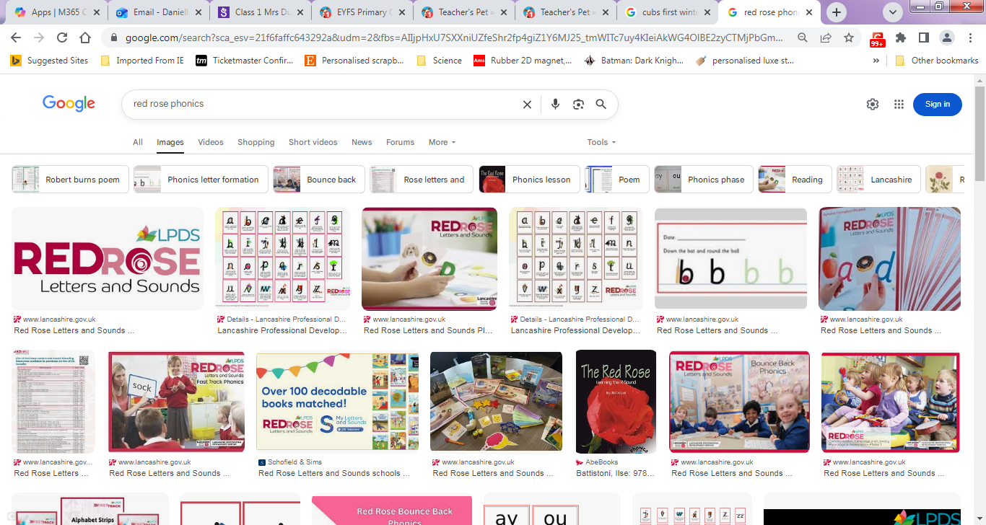
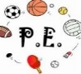
PE Days
Class 1: Tuesday and Thursday
Class 2: Tuesday and Thursday
All children are to come into school in their PE kits on these day. Please ensure the children are wearing trainers and all PE kit is named.
NO EARRINGS!

Phonics: The children have started learning Level 3 sounds in our phonic lessons. We have phonic lessons daily where the children learn a new sound.
It is fast paced and they learn 3 sounds a week. Please practise these sounds at home with your child.

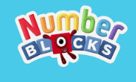
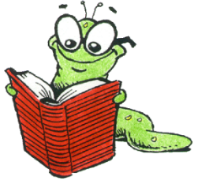
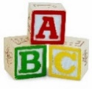
Reading
Please read every night with your child. Repetition is the key to developing confidence and understanding.
1st read: decode the story
2nd read: understand the story
3rd read: enjoy the story
Things to do before you turn 5 ¾
During your child's time in our Reception we want them to have experience lots of different things. With this in mind we have created our own "50 things to do before you're 5 ¾" based on the National Trust's 50 things to do before you are 11 ¾. Our aim for this half term is for all children to experience:
· Dancing in the rain
· An Easter egg hunt
· Make a mud pancake

Helping at home
The children are becoming more and more independent. Thank you for your help with this.
Please continue to practise:
- Taking shoes and socks off and putting them on again.
- Taking off and putting on jumpers and cardigans
- Putting coats on.
- Turning sleeves in coast and jumpers the correct way.
- If your child is able to write their name please encourage them not to use capital letters. The capital letter is just for the start of their name.
We go outside no matter the weather. If you have not already done so please send in a pair of named wellies.

We would like to start brushing our teeth after lunch. If you have not already done so please send in a tooth brush.

Please name all coats, jumpers, hats, scarves and gloves. Children tend to leave items outside at lunchtimes, they must be named!

Maths
We will continue to be using maths mastery and the Numberblocks to support us with our maths lessons. The most important thing you can do at home is to continue to count, count, count.
Count everything, steps, stairs, and pieces of fruit anything at all. This helps with the children 1:1 correspondence. Identify numbers when you are out and about: doors, menus and packets.
English
This half term we will continue to focus heavily on fine motor skills to help make the writing process easier for the children. The children will take part in a variety daily fine motor skills activities each day

Our class stories this half term are:
Cubs first winter, How to catch a star and Whatever next.

