 | Autumn Term 2025 |  |  | Spring Term 2026 |  | Summer Term 2026
 | Autumn A  ( 7 ½ weeks) |  | Autumn B  (7 weeks) | Spring A  (6 weeks) | Spring B  (5 weeks) | Summer A  (6 weeks) |  | Summer B  (6 ½ weeks)
English  Books | LPDS Bridging Unit  A Bear called Paddington  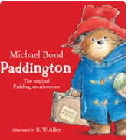  Paddington by Michael Bond |  | LPDS Unit: There’s No Place Like Home  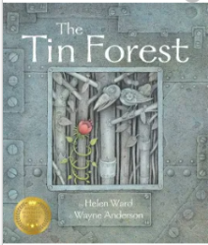  The Tin Forest by Helen Ward | LPDS Unit:  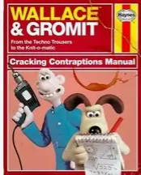  Wallace and Gromit | LPDS Unit: The Iron Man  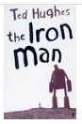  The Iron Man by Ted Hughes | LPDS Unit: Water, Water Everywhere!  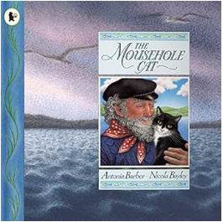  The Mousehole Cat by Antonia Barber |  | LPDS: How Does your Garden Grow  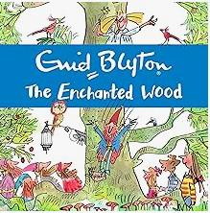  The Enchanted Wood by Enid Blyton
Theme: Narrative  Non-fiction  Poetry | An Adventure Story  Non-Chronological Report |  | Folk Tales  (3 Weeks)  Poems with a theme | Biography  Explanations | Novel as a Theme  (4 Weeks)  Recount: Diaries  The coming of the iron man | Stories with a Theme  (3 Weeks)  Information books  Poems with a theme (Water Dance) |  | A Tale of Mystery/Adventure  (3 – 4 Weeks)  Explanation  Classic poetry (Animal spider)
Maths

Creative Topic Title | Creative:  Cavemen to Craftsmen |  |  | Humanities theme:  It’s All Greek to me |  | STEM theme:  Sounds of the River
Science | Rocks and plants |  |  | Animals including humans |  | Sound
Geography |  |  | Our European Neighbours! | Continent: Europe  Country: Greece |  | Bodies of Water: River Ribble
History | Stone Age to Iron Age |  |  |  | Ancient Greece |  | Anglo-Saxon and Scots
Computing | Project Evolve |  | Data handling: Interactive story graphs | Project Evolve | Presentation: Interactive comics (Ancient Greece?) | Project Evolve |  | Programming: Animations in Scratch
Art | Pastels/ printings – cave painting |  |  |  | 3D Clay: Ancient Greek pottery | Collage: Robin Brooks and the British Isles (River Ribble)
DT |  |  | Structures: Make a catapult (link to Stone Age?) or picture frame (Christmas?) | Cooking and Nutrition: Greek Mezze |  |  |  | Mechanisms: Gears, pulleys and cams: Make a celebration card
French | French Culture  Numbers  The alphabet |  | Names  Greetings  Classroom instructions | Going to school (transport) | School subjects | My family |  | At the farm
PE | Outdoor: Invasion (Handball)  Indoor: Baseline – key skills (gymnastics) |  | Outdoor: Net and wall – core task  Indoor: Gymnastics 1 | Outdoor: OAA Team work and problem-solving  Indoor: Greek dance | Outdoor: Invasion (netball)  Indoor: Gymnastics | Outdoor: Target games (boccia)  Indoor: Target games (dodgeball) |  | Outdoor: Striking and fielding (cricket)  Indoor: Athletics
Music | Glockenspiel 1 |  | Let Your Spirit Fly: Match Girl’s Christmas  LISTEN: Music from around Europe | Three little birds  LISTEN: Greek Music | Lean on Me  KS2 show | The dragon song  LISTEN: Sounds of nature |  | BBC Music: Heroes of Troy
PSHE | Relationships: Friendships | Relationships: Safe |  | Relationships: Hurtful behaviour and bullying | Health and Wellbeing: Keeping safe | Wider world: Shared responsibility and community |  | Wider world: Communities
RE  Key question  (must be taught) | Islam: Why is the Prophet Muhammad an example for Muslims? |  | Christianity (God) How and why have some people served God? | Sikhism: Why are the Gurus important to Sikhs? | Christianity (Jesus) What does it mean to be a disciple of Jesus? | Hinduism: Why is family an important part of Hindu life? |  | Christianity (Church) What do Christians mean by “The Holy Spirit”?
Possible Enrichment/Enhancements
Enrichment and Enhancement |  |  | Visit to a church |  | Greek Day in school | Trip to the River Ribble  Litter picking? (Community) |  | Trip to a farm
Outdoor Learning/  Forest school | Rock printing  Cave drawing  Chalk drawing

