 | Autumn Term 2025 |  |  | Spring Term 2026 |  | Summer Term 2026
 | Autumn A |  | Autumn B | Spring A | Spring B | Summer A | Summer B
English  Books | LPDS Bridging Unit  The Lion, the Witch and the Wardrobe  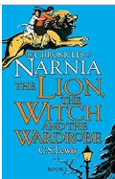  The Lion, the Witch and the Wardrobe  By C. S. Lewis  Integrated Unit of fiction and non-fiction |  | LPDS Unit: Goodnight Mr Tom  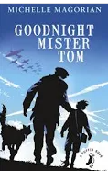  Good Night Mr Tom by Michael Magorian  Integrated Unit of fiction and non-fiction | LPDS Unit: A Kingdom United  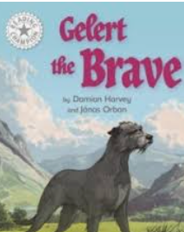  The Legend of Gelert  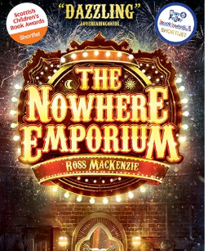 | LPDS Unit: Heroes and Villains  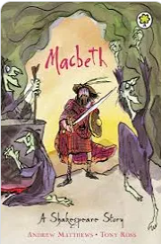  Macbeth by William Shakespeare  Not fiction hybrid | LPDS: Faster, Higher, Stronger  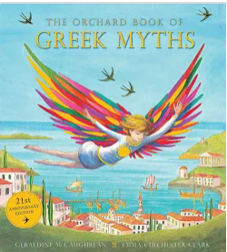  A Selection of Greek Myths | LPDS: Last Push Pack – Wonder  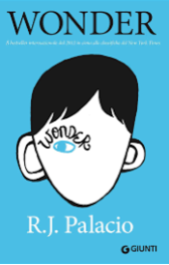  Wonder by R.J. Palacio (Read the book with the class before the unit starts)
Maths | Number and Place Value  Addition and subtraction  Multiplication and  Division |  | Area and Perimeter  Fractions  Geometry  Assessment | Number and Place Value - Decimals  Addition and subtraction – Decimals  Measurements – Mass and Capacity  Angles, lines and shape | Multiplication and Division  Fractions  Decimals and percentages  Statistics  Assessment | Place value – including powers  Four operations  Volume  Fractions, decimals and percentages | Position and Direction  Statistics  Time and Money  Assessment
Creative Topic Title | Let There Be Light! |  |  | A World of People and Power |  | Mapping the past, shaping the future.
Science | Light | Living things and their habitats |  |  | Forces | Earth and Space
Geography | Sustainability |  |  | Africa through the eyes of the people |  | North America, Canada and the Caribbean
History |  |  | WW1 |  | The Vikings and Anglo Saxons | The Atlantic Slave Trade
Computing | Project Evolve |  | Animation | Project Evolve | Programming | Data Handling | Project Evolve
Art |  |  | Collage | Printing (Lino) |  | 3D Model
DT | Cooking and Nutrition |  |  |  | Structures |  | Mechanism
French | Snacks and drinks at the supermarket |  | Body parts | At the doctors | Jobs | Travel the world | Nationality - euros
PE | Hockey  Gymnastics |  | Netball  Orienteering | OAA  Dance | Tennis  Gymnastics | Cricket  Dance | Rounders  Athletics
Music | Recorder 1 |  | WW1 Music | Jazz | Viking saga | Living on a prayer | Show
PSHE | Friendships |  | Safe relationships | Drugs, alcohol and tobacco | Keeping safe | Pressure and Independence  *Puberty | Aspirations, work and career.
RE  Key question  (must be taught) | God |  | Hinduism | Islam | Jesus | Church | Judaism
Possible Enrichment/Enhancements
Enrichment and Enhancement

Outdoor Learning/
Forest school

