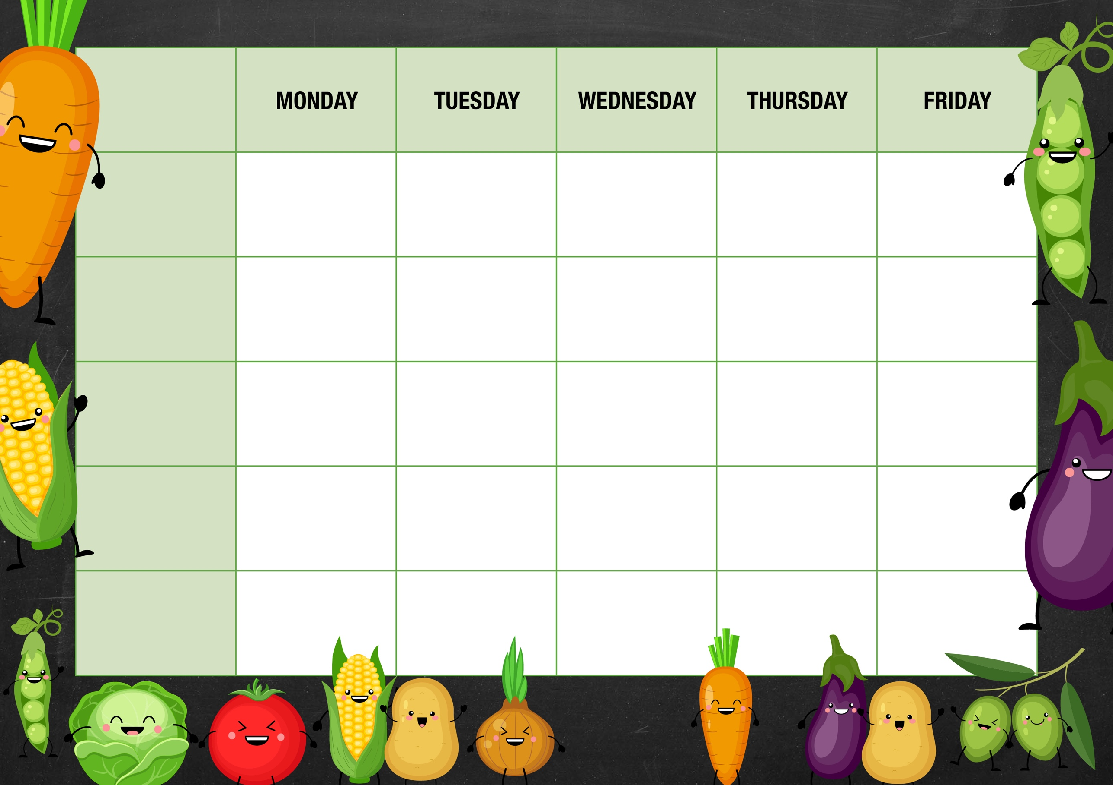
V
Chicken Korma
Curry
Rice
Naan bread
Sweetcorn
Chicken Burger
Curly Fries
Mixed Salad

Fresh fruit
Yoghurt

Jacket potatoes
choice of Tuna, Beans or Cheese.
Salad bar

DESSERTS

JACKET AND SANDWICHES
Roast Beef
Yorkshire pudding
Mashed potatoes
Broccoli/Peas
Gravy
Pasta Bolognaise
Garlic Bread
Mixed Salad

Sausage Roll
Chips
Baked Beans

Fish Finger Wrap
Lettuce, cheese, sauce
Corn on the cob
Chinese Noodles & Spring Rolls

Cheese Whirl
Mashed potatoes
Broccoli or Beans

Macaroni Cheese Garlic Bread

Pizza
Chips
Baked Beans

Jacket potatoes
choice of Tuna, Beans or Cheese.

Assorted sandwiches

Jacket potatoes
choice of Tuna, Beans or Cheese.

Assorted sandwiches

Fresh fruit
Yoghurt

Fresh fruit
Yoghurt

Fresh fruit
Yoghurt

Fresh fruit
Yoghurt

Shortbread
Flapjack
Chocolate muffin
Jelly
Ice cream
MAIN MEAL
Week 1
VEGETARIAN OPTION

