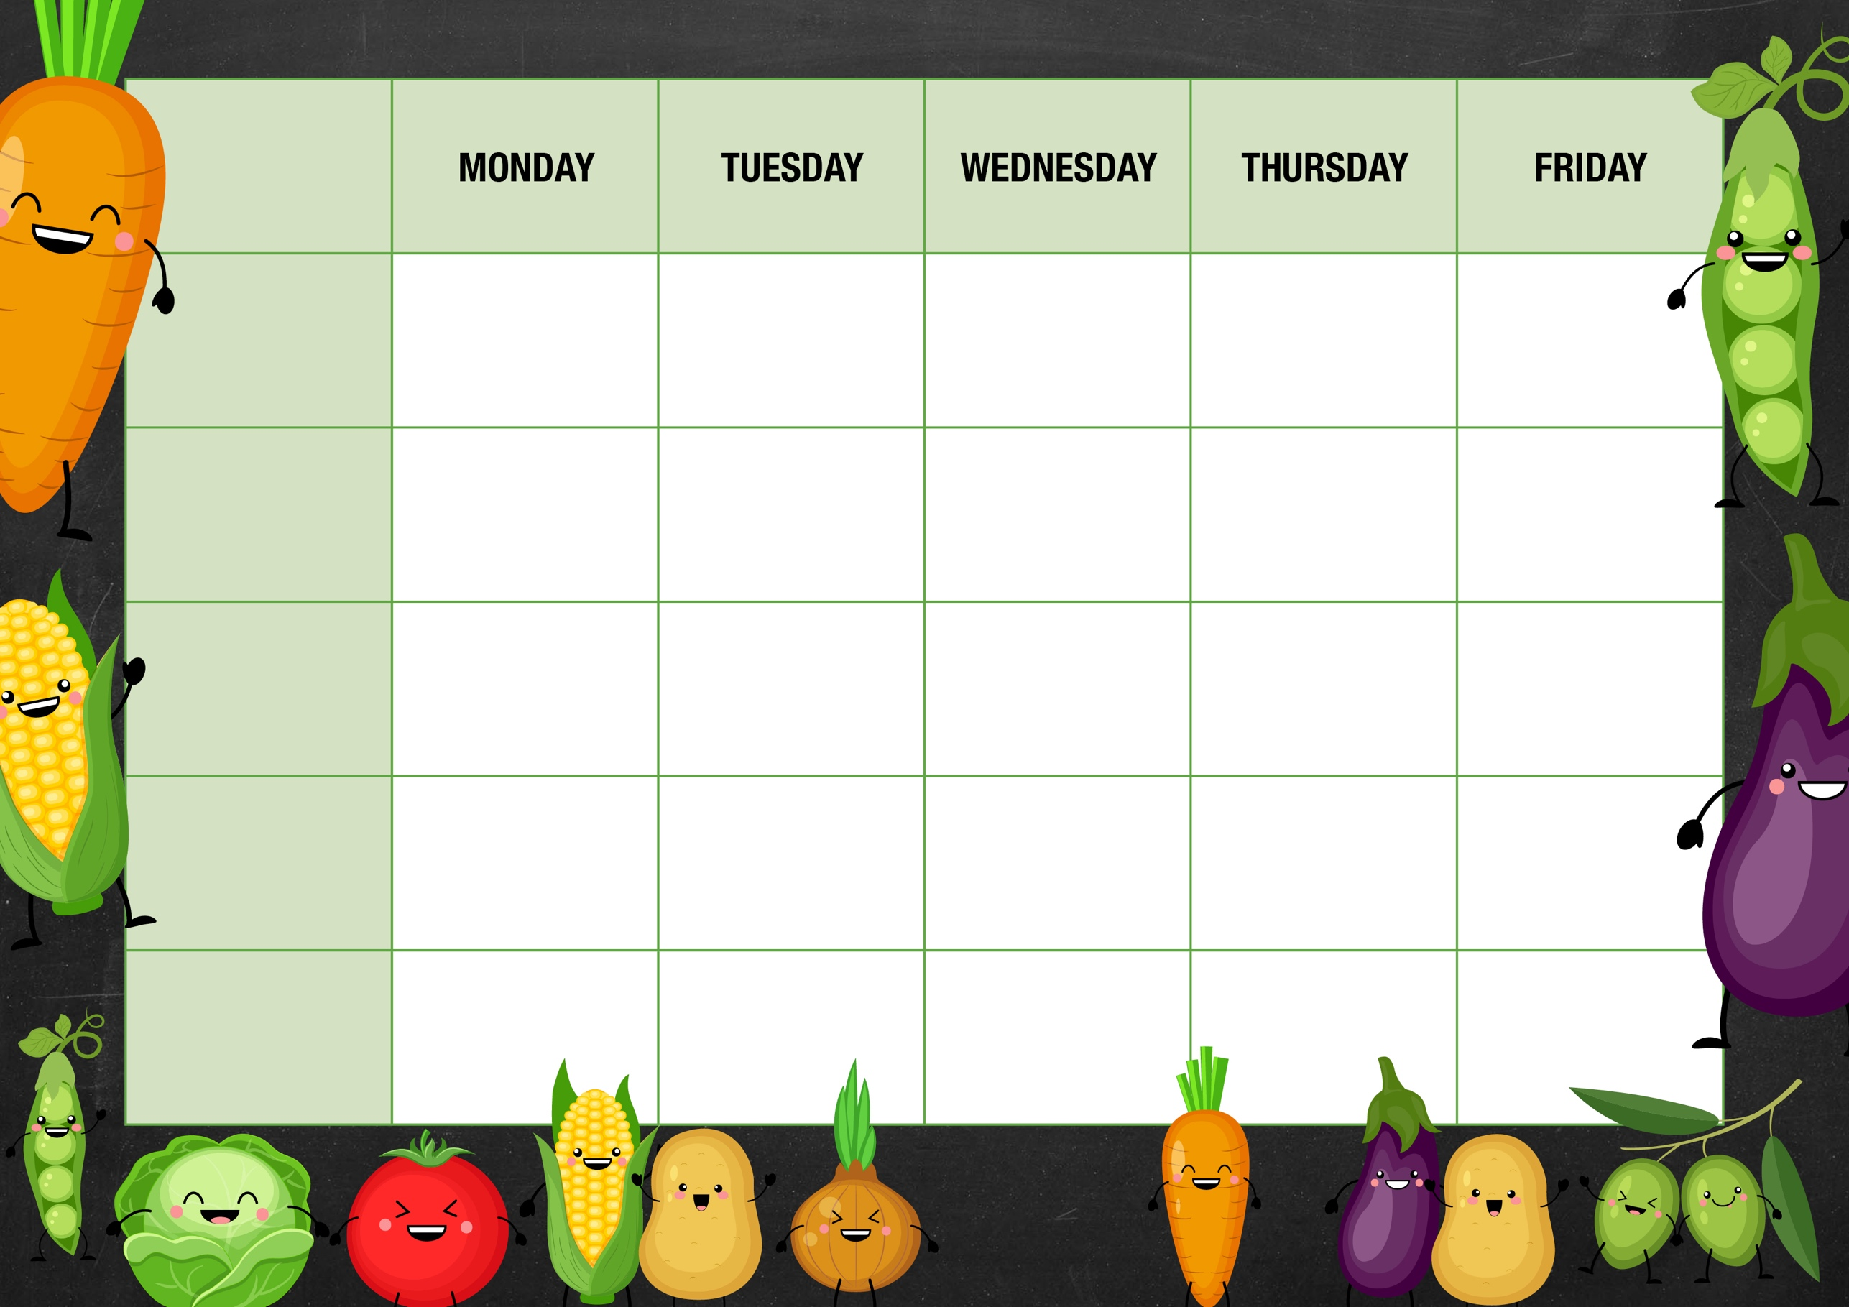
V
Jacket potatoes
choice of Tuna, Beans or cheese.

Fresh fruit
Yoghurt

Roast Chicken/Quorn Dinner
Mashed Potato
Mixed Vegetables
Iced Sponge
Strawberry Whip

JACKETS AND SANDWICHES
Chicken & Tomato Pasta Bake
Garlic dough balls
Mixed Salad
Mild Chilli Beef Tacos
Rice
Mixed Salad

BBQ Chicken
Rainbow Rice

Beefburger
Chips
Baked Beans
Cheese & Onion Roll
Wedges
Mixed Salad
Southern Style Veggie Nuggets served on a Bun
Mixed salad.
Cheese Flan
Mashed Potato
Mixed Vegetables

Tomato & Mascarpone Pasta
Garlic dough balls
Mixed salad
Fish Fingers
Chips
Baked Beans
Jacket potatoes
choice of Tuna, Beans or cheese.
Assorted sandwiches

Jacket potatoes
choice of Tuna, Beans or cheese.

Assorted sandwiches

Fresh fruit
Yoghurt

Fresh fruit
Yoghurt

Fresh fruit
Yoghurt

Fresh fruit
Yoghurt

Frozen yoghurt
Raspberry Bun
Rainbow cookie
MAIN MEAL
Week 2
VEGETARIAN OPTION
DESSERT
DESSERT

