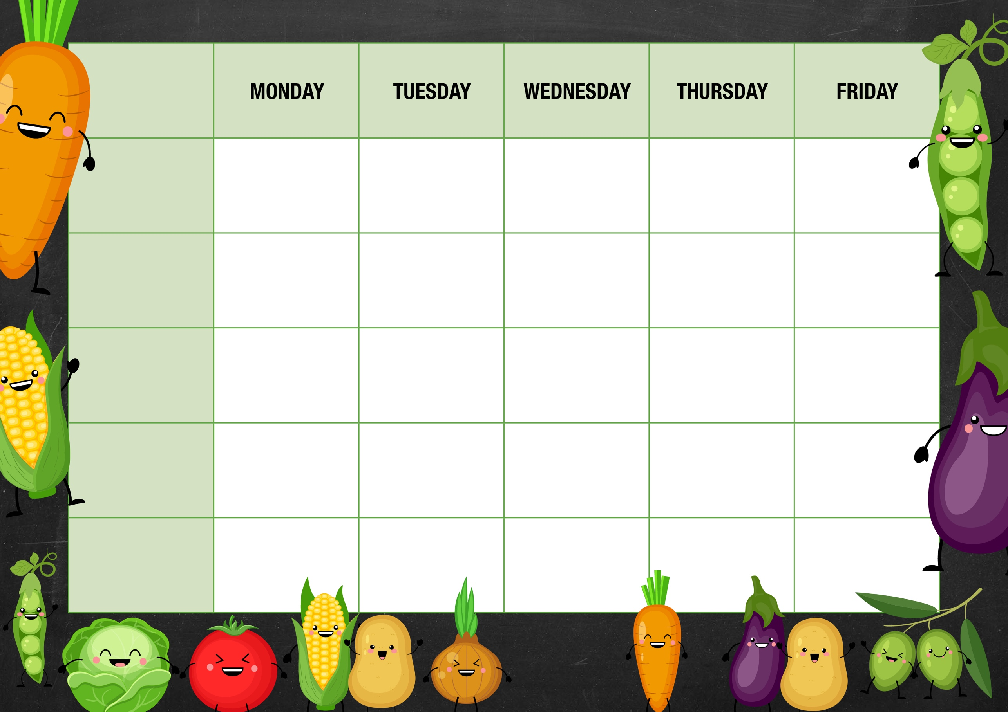
V
JACKETS AND SANDWICHES

Fish Finger Wrap
Lettuce, cheese, sauce
Corn on the cob

Chicken Nuggets
Chips
Baked Beans

Chicken Tikka
Rice
Mini Naan Bread
Green beans

Jacket potatoes
choice of Tuna, Beans or cheese.

Meat & Potato Pie
Peas
Gravy

Vegetarian All day breakfast

All day Breakfast
Sausage
Omelette
Hash browns
Baked beans
Vanilla Muffin
Chocolate cookie
Chicken Wraps
Lettuce
Cheese
BBQ sauce
Corn on the cob

Veggie Quesadilla
Corn on the cob

Tomato & Mascarpone Pasta
Salad
Garlic Bread

Pizza
Chips,
Baked Beans

Jacket potatoes
choice of Tuna, Beans or cheese.

Assorted sandwiches

Jacket potatoes
choice of Tuna, Beans or cheese.

Assorted sandwiches

Fresh fruit
Yoghurt

Fresh fruit
Yoghurt

Fresh fruit
Yoghurt

Fresh fruit
Yoghurt

Fresh fruit
Yoghurt

Fruit Jelly

Pink Cake
custard
Pancakes
Chocolate sauce
MAIN MEAL
Week 3
VEGETARIAN OPTION
DESSERT
DESSERT

