Fulwood and Cadley Primary School

Curriculum Policy
September 2026
Know more. Remember more. Apply more.
Wish it. Dream it. Do it. Be Unique.

Policy information
Policy owner | Leesa Pearce
Approved by | Governors
Review cycle | Annual
Next review | September 2027

Contents
1. Curriculum Intent
2. Curriculum Entitlement and Architecture
3. Learning on a Page (LoaP)
4. Big Questions and Curriculum Journeys
5. Curriculum Threads and Progression
6. Substantive and Disciplinary Knowledge
7. Vocabulary
8. Prior Learning, Retrieval and Making Learning Stick
9. Misconceptions and Hinge-Point Questions
10. Adaptive and Inclusive Curriculum
11. Working Walls and the Visible Curriculum Journey
12. Developing Independent Learners - Help Yourself First
13. Curriculum Enrichment and Educational Visits
14. Curriculum Assessment
15. Subject Leadership and Quality Assurance
16. Roles and Responsibilities
17. Monitoring and Review
Appendix: Retrieval and Curriculum Strategies

1. Curriculum Intent
At Fulwood and Cadley Primary School, our curriculum is designed to ensure that pupils develop secure, connected knowledge and understanding across all subjects. Learning is carefully sequenced so that pupils build knowledge over time, make meaningful connections with prior learning and increasingly apply what they know with independence.
Our ambition is that pupils know more, remember more and apply more. The curriculum is broad, balanced and ambitious for all pupils. It develops both academic knowledge and the character, curiosity and confidence pupils need to thrive.
Our school values - Courage, Respect, Aspiration, Resilience, Imagination and Determination - are reflected in curriculum experiences and in the way pupils are encouraged to engage with learning.
The curriculum is underpinned by the principle that learning involves a lasting change in what pupils know or can do. Consequently, curriculum design, teaching, retrieval and assessment work together to strengthen pupils’ long-term memory and their ability to use knowledge in increasingly sophisticated ways.

2. Curriculum Entitlement and Architecture
The curriculum is planned from EYFS to Year 6 so that pupils encounter a coherent progression of knowledge, vocabulary and disciplinary practice. Where appropriate, subjects are organised through a two-year rolling cycle to reflect the school’s mixed-age structure while preserving progression and full curriculum entitlement.
Element | Fulwood and Cadley expectation
National entitlement | Curriculum plans secure appropriate statutory coverage while allowing subject leaders to shape coherent, purposeful learning journeys.
Two-year cycles | Cycle A and Cycle B are mapped so that pupils receive breadth without unnecessary repetition and so that knowledge builds across phases.
Progression | Subject curriculum maps show how important knowledge, vocabulary and disciplinary practice develop from earlier to later learning.
Unit design | Each unit has a clear intended end point, expressed through a Big Question and supported by a Learning on a Page document.
Connections | Teachers make deliberate links to prior learning, curriculum threads and future learning so that pupils build connected rather than isolated knowledge.
Subject integrity | Cross-curricular links are used when they strengthen learning; they do not replace the distinctive knowledge and disciplinary practices of individual subjects.

3. Learning on a Page (LoaP)
Learning on a Page is the core unit-level curriculum document used to support consistent implementation and professional dialogue. It makes the intended curriculum explicit without becoming a lesson-by-lesson script.
LoaP element | Purpose
Big Question | Defines the purposeful end point of the unit and gives the learning journey a clear destination.
Prior learning | Identifies the knowledge pupils need to retrieve and connect to new learning.
Curriculum threads | Shows where important concepts recur and develop across units, phases and cycles.
Substantive knowledge | Identifies the essential facts, concepts and content pupils should know and remember.
Disciplinary knowledge | Identifies how pupils learn to think, enquire, investigate, interpret, create or communicate within the subject.
Key vocabulary | Identifies the subject-specific language pupils need to understand and use accurately.
Misconceptions | Anticipates likely errors or misunderstandings so teaching can address them deliberately.
Hinge-point questions | Identifies key checks that reveal whether pupils understand the essential concept and are ready to move on.
Retrieval | Plans opportunities to revisit important knowledge within and beyond the unit.
Adaptive / NASEN considerations | Identifies likely barriers and practical adaptations that support access to the intended curriculum without lowering ambition.

Teachers use LoaP alongside subject curriculum maps and their professional judgement. It supports planning; it does not require every class to complete identical activities.

4. Big Questions and Curriculum Journeys
Each unit is organised around a Big Question. The Big Question gives pupils a reason for learning and helps teachers maintain focus on the intended curriculum end point. It should be introduced at the beginning of the unit, revisited as knowledge develops and answered with increasing depth by the end.
- The Big Question is visible within the learning environment.
- Individual lessons contribute knowledge or disciplinary understanding needed to answer it.
- Teachers make the connection between each lesson and the wider journey explicit.
- The final response provides an opportunity for pupils to draw together and apply what they have learned.
- A final response is not the only evidence of learning; teachers also draw on retrieval, discussion, pupil work and subject-specific assessment.

5. Curriculum Threads and Progression
Curriculum threads are recurring concepts or areas of knowledge that help pupils connect learning over time. Subject leaders identify and map these threads so that teachers can make progression visible and pupils can recognise how their understanding is becoming richer.
Threads are not additional content. They provide a way of connecting the planned curriculum across year groups and cycles. Teachers should refer back to relevant earlier learning and make explicit when pupils are meeting a familiar concept in a new context.

6. Substantive and Disciplinary Knowledge
Our curriculum deliberately develops substantive and disciplinary knowledge together.
Knowledge type | Meaning | Examples
Substantive knowledge | The facts, concepts, vocabulary and content that form the body of knowledge within a subject. | For example, geographical knowledge of rivers; historical knowledge of a period; scientific knowledge of forces.
Disciplinary knowledge | The ways pupils learn to think, work and establish knowledge within a subject. | For example, geographical fieldwork; historical enquiry and evaluation of evidence; scientific investigation and interpretation of results.

Pupils need sufficient substantive knowledge to engage meaningfully in disciplinary activity. Equally, disciplinary knowledge enables pupils to use, test, interpret and communicate substantive knowledge in subject-appropriate ways.

7. Vocabulary
Vocabulary is a curriculum entitlement. Subject-specific words are selected deliberately because they enable pupils to access concepts, explain their thinking and communicate with increasing precision.
- Key vocabulary is identified on LoaP documents.
- Teachers explicitly explain and model new vocabulary rather than relying on incidental exposure.
- Pupils encounter vocabulary through speaking, reading and writing.
- Important vocabulary is revisited through retrieval and subsequent units.
- Working walls and models support pupils to use vocabulary independently.
- Teachers check that pupils understand vocabulary in context, not simply that they can repeat a definition.

8. Prior Learning, Retrieval and Making Learning Stick
New learning is connected to what pupils already know. Teachers therefore identify and activate relevant prior knowledge before introducing new concepts. Retrieval is used throughout and beyond a unit to strengthen memory and reveal gaps that require further teaching.
When | Purpose | Possible approaches
Before new learning | Activate the specific prior knowledge needed to understand what comes next. | Focused questions, image prompts, quick diagrams, mind maps, agree/disagree, brief retrieval grids.
During a unit | Strengthen recently taught knowledge and connect it to new learning. | Low-stakes quizzes, oral rehearsal, mini-whiteboards, Give Me Five, explain-and-elaborate, retrieval questions.
After a unit | Revisit important knowledge after time has passed and check what remains accessible from memory. | Spaced retrieval grids, mixed-subject questions, sticky-knowledge prompts, diagrams from memory, short quizzes.
Across later units | Connect previous knowledge to a new context and deepen curriculum threads. | Prior-learning questions, comparison, explanation and deliberate reference to earlier units.

Retrieval is purposeful rather than a generic starter. Teachers select knowledge because it is important to retain or because it is needed for current learning.

9. Misconceptions and Hinge-Point Questions
Likely misconceptions are identified during curriculum planning so that teachers can address them before they become embedded. Hinge-point questions are planned at important moments in learning to reveal whether pupils have understood the essential concept.
A hinge-point question should allow all pupils to respond. Responses may be gathered through mini-whiteboards, show-me responses, carefully structured answer choices, oral responses or another efficient whole-class method. The purpose is not to generate evidence for its own sake; it is to inform the next teaching decision.
What the response shows | What may happen next
A significant misconception remains | Re-teach the concept, use a different representation or explanation and check again.
Partial understanding | Provide further modelling, guided practice or targeted questioning.
Secure understanding | Move pupils towards independent application.
Secure and fluent understanding | Deepen through explanation, comparison, reasoning, enquiry or application in a less familiar context.

Hinge-point questions are therefore part of curriculum implementation and formative assessment. They help ensure that the planned curriculum becomes the learned curriculum.

10. Adaptive and Inclusive Curriculum
All pupils are entitled to an ambitious curriculum. Adaptive teaching and reasonable adjustments enable pupils to access the same important curriculum goals wherever appropriate. Adaptation should remove barriers rather than unnecessarily reduce curriculum content.
- Identify likely barriers through LoaP/NASEN considerations and knowledge of individual pupils.
- Pre-teach essential vocabulary or background knowledge where this improves access.
- Use visuals, manipulatives, models, scaffolds and chunked instructions where appropriate.
- Provide additional guided practice while maintaining the intended conceptual goal.
- Use accessible resources and technology where needed.
- Deploy adults to promote participation and independence rather than dependency.
- Remove scaffolds as pupils become more secure.

11. Working Walls and the Visible Curriculum Journey
Working walls are active learning tools. In foundation subjects, the learning journey should develop visibly over the unit so pupils can see how individual lessons connect to the Big Question.
- The Big Question remains visible throughout the unit.
- The learning journey or “road” develops as teaching takes place rather than being completed in advance.
- Key vocabulary, models, examples, important knowledge and pupil thinking are added purposefully.
- Where several subjects are displayed side by side, each retains its own disciplinary identity and curriculum journey.
- Pupils are explicitly taught how to use the working wall and other classroom resources independently.
- The final learning should make clear how accumulated knowledge enables pupils to address the Big Question.

12. Developing Independent Learners - Help Yourself First
At Fulwood and Cadley, independence is explicitly taught. Independence does not mean working without support; it means knowing how to use the knowledge, strategies and resources already available before relying on an adult. Our aim is to develop pupils who know what to do when they do not immediately know what to do.

Help Yourself First
Before asking an adult for help, pupils are encouraged and taught to select appropriate support for themselves. Depending on the subject, age and task, this may include:
- revisiting learning from previous lessons in their books;
- using the current working wall and visible curriculum journey;
- referring to models, worked examples, key vocabulary, success criteria and other displayed prompts;
- using classroom resources and independence baskets;
- revisiting prior-learning and retrieval materials;
- using iPads appropriately for agreed research, reference or curriculum resources;
- accessing curriculum loan boxes, non-fiction texts, atlases, reference books and other resources from the school library;
- using knowledge organisers or other subject-specific resources where these support the curriculum;
- rehearsing or discussing thinking with a peer when this has been identified as an appropriate strategy.
Adults model how, when and why these resources should be used. Pupils are not expected simply to know how to work independently: teachers explicitly teach the routines and strategies that make independence possible. As pupils become more secure, prompts and scaffolds are gradually withdrawn and pupils are expected to select increasingly appropriate resources for themselves.
The school library is therefore part of the wider curriculum resource offer, not solely a source of reading books. Curriculum loan boxes and carefully selected reference materials enable pupils to research, revisit and extend learning independently.

13. Curriculum Enrichment and Educational Visits
Curriculum enrichment is deliberately planned as part of the two-year curriculum cycle. Educational visits and residential experiences are designed to deepen curriculum learning, broaden pupils' experiences, build cultural capital and provide memorable contexts to which classroom learning can connect.
Cycle | Planned entitlement
Cycle A | An overnight residential stay or stays, planned to enrich the curriculum and develop independence, confidence, relationships and wider life experiences.
Cycle B | A planned day trip linked to the curriculum, providing first-hand experience that strengthens and extends classroom learning.

Fussell Travel supports the school with the organisation of planned educational visits and residential experiences. Visits are mapped in advance so that enrichment is equitable, purposeful and connected to the curriculum rather than being added as an isolated activity.
Teachers make explicit links before, during and after visits so that pupils connect first-hand experiences to the knowledge, vocabulary and disciplinary understanding being developed in school. Appropriate risk assessment, safeguarding, accessibility and reasonable adjustments are considered so that all pupils can participate as fully as possible.

14. Curriculum Assessment
Curriculum assessment asks whether pupils have learned the intended curriculum: what they know, what they remember, how securely they can use it and where gaps remain. Assessment is proportionate and subject-appropriate.
Evidence | How it is used
Retrieval and hinge questions | Reveal immediate understanding, misconceptions and retention.
Pupil work and independent outcomes | Show how pupils apply substantive and disciplinary knowledge without excessive support.
Big Question responses | Provide an opportunity to synthesise and communicate learning from across a unit.
Pupil voice | Explores what pupils have learned, what prior knowledge helped them, how learning connects across the curriculum, how confidently they use subject vocabulary and what strategies/resources they use when they become stuck.
Subject-specific assessment | Used where appropriate to the discipline and curriculum, rather than applying one generic assessment model to every subject.
Longer-term retrieval | Checks whether important knowledge remains accessible after the unit has ended.

Assessment information is used to adapt teaching, inform future planning and evaluate curriculum implementation. It should not create unnecessary workload or encourage superficial evidence gathering.

15. Subject Leadership and Quality Assurance
Subject leaders are responsible for maintaining a clear overview of their curriculum from intent through to implementation and impact. Leadership is developmental and evidence-informed.
Subject leaders maintain | Subject leaders evaluate
A coherent curriculum map across the school. | Whether planned knowledge and disciplinary practice are being taught and learned.
Clear Cycle A and Cycle B sequencing where appropriate. | Whether progression and curriculum threads are visible across phases.
Current LoaP documents with Big Questions, vocabulary, misconceptions, hinge questions and retrieval. | How well pupils remember and connect learning through pupil voice, book looks and learning walks.
A clear understanding of subject-specific pedagogy and expected outcomes. | Whether adaptations enable pupils with SEND and other needs to access the intended curriculum.
Resources and guidance that support teachers without creating unnecessary workload. | What professional development or curriculum refinement is needed next.

Regular curriculum-lead and subject-leader dialogue supports consistency, reflection and the development of subject leadership. Monitoring should lead to proportionate, clearly identified next steps.

16. Roles and Responsibilities
Role | Responsibility
Governors | Provide strategic oversight and hold leaders to account for the quality, breadth and ambition of the curriculum.
Headteacher and SLT | Set whole-school curriculum expectations, ensure appropriate resourcing and professional development, and evaluate implementation.
Curriculum Lead | Maintain whole-school curriculum coherence; support and develop subject leaders; oversee LoaP, curriculum threads and quality assurance.
Subject Leaders | Design, maintain and evaluate their subject curriculum; support colleagues with subject knowledge and pedagogy; identify strengths and next steps.
Teachers | Know the intended curriculum, connect learning to prior knowledge, teach key vocabulary and knowledge explicitly, check understanding and adapt responsively.
Teaching Assistants | Support access to the intended curriculum under teacher direction, including pre-teaching, scaffolding and targeted practice while promoting independence.
Pupils | Engage with the curriculum, use subject vocabulary, make connections, retrieve prior learning, use Help Yourself First resources appropriately and increasingly explain, apply and present what they know independently.
Parents / carers | Support learning and enrichment at home and work in partnership with school.

17. Monitoring and Review
The curriculum is monitored as a connected system rather than through isolated activities. Leaders evaluate the relationship between the intended curriculum, what is taught and what pupils have learned.
- Curriculum maps and LoaP documentation.
- Professional dialogue and subject-leader development meetings.
- Learning walks and lesson visits.
- Book looks and review of independent outcomes.
- Pupil voice and use of subject vocabulary.
- Working walls and the visibility of curriculum journeys.
- Assessment and retrieval information where appropriate.
- Provision and curriculum access for pupils with SEND and other identified groups.
Findings are used to celebrate strengths, refine curriculum design, target professional development and agree proportionate next steps. This policy is reviewed annually by the Senior Leadership Team and Governors.

Appendix: Retrieval and Curriculum Strategies
The March 2026 curriculum document contained a range of practical retrieval and active-learning ideas. These remain useful as a menu of strategies, but they are not a prescribed lesson structure. Teachers select approaches according to the knowledge being retrieved and the needs of the pupils.

The original Recall - Understand - Apply - Check - Extend model
The original model is retained below as part of the school’s curriculum-development journey. Its principles remain visible within the updated policy: retrieve prior knowledge, teach and model clearly, provide application, check understanding and deepen learning. These processes may occur repeatedly and flexibly across a unit rather than as a fixed sequence.
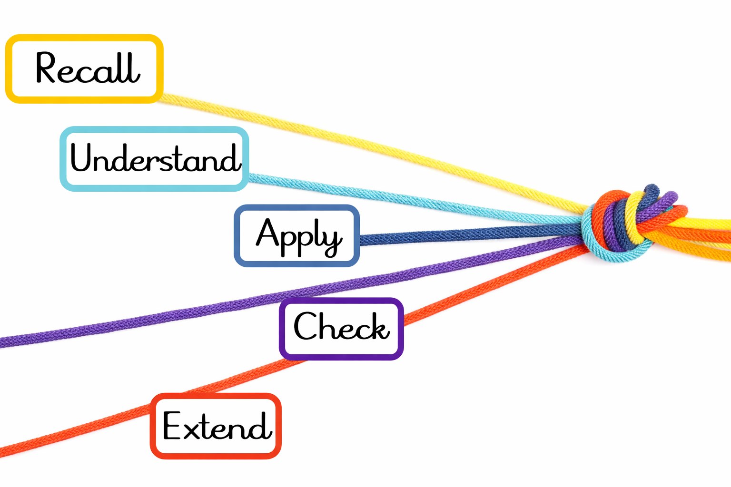

Examples of retrieval strategies
Strategy | How it may be used
Opening question / image prompt | Activate relevant prior knowledge and expose starting points.
Mind map / KWL | Organise what pupils already know and revisit how understanding has changed.
Give Me Five | Rapidly retrieve a small set of important facts or examples.
Expand and Elaborate | Start with a known fact and add connected detail, explanation or evidence.
Pyramid Check | Move from core knowledge towards increasingly demanding questions.
Retrieval grid | Mix questions from recent and more distant learning to support spaced retrieval.
Sticky Knowledge Jars | Rotate questions from last week, two weeks ago and further back to revisit knowledge over time.
Diagram from memory | Reconstruct a previously taught diagram and explain the relationships shown.
Write Knowledge, Give Knowledge, Get Knowledge | Retrieve individually, then use structured peer exchange to add and discuss remembered knowledge.

Original retrieval examples retained
The following images from the previous curriculum document are retained as practical examples of retrieval approaches.
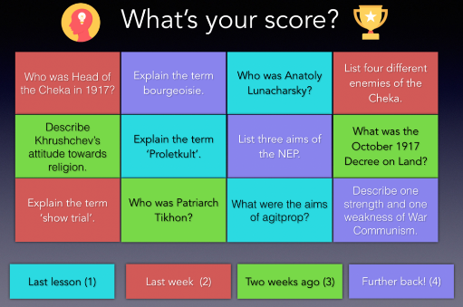

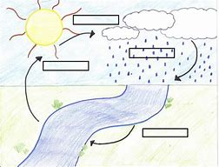
Wish it. Dream it. Do it. Be Unique.

