 | Autumn Term 2026 |  | Spring Term 2027 |  | Summer Term 2027
 | Autumn A | Autumn B | Spring A | Spring B | Summer A | Summer B
English | LPDS Bridging Unit  Harry the Happy Mouse  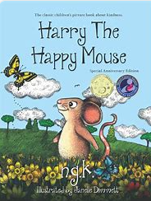  Narrative  Non Fiction – posters  Poetry | Family Album (tradition tales)  Fairy Tales  3 Little Pigs  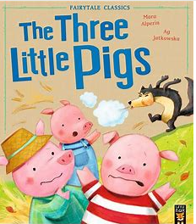  Instructions | The Owl Who is Afraid of the Dark  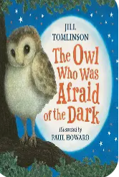  Recount  Letters  Classic Poetry – The Owl and the Pussycat | Stories with familiar setting  Mud Puddle Farm  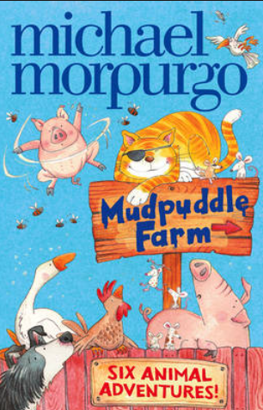  Recount  No Riddles | Lighthouse Keeper’s Lunch  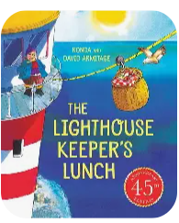  Explanations  Poems on a theme | Persuasive leaflets  Create own farm  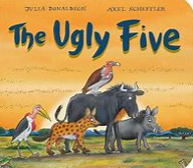  The Great Outdoors: Ugly Five (The big five – animals)
Maths | Year 1  Place Value  Length and Mass  Addition and subtraction  2D and 3D shapes  Year 2  Place Value  Length and Mass  Addition and subtraction  2D and 3D shapes | Year 1  Sequencing and Sorting  Fractions  Capacity and Volume  Time  Assess and Review  Year 2  Counting, multiplication and sorting  Statistics  Fractions  Capacity and Volume  Time  Assess and Review | Year 1  Place Value  Mass  2D and 3D shapes  Counting Money  Multiplication  Division  Year 2  Place Value  Mass, Capacity and Volume  Addition and Subtraction  Money  Multiplication and Division | Year 1  Length and Mass  Addition and Subtraction  Fractions  Position and Direction  Time  Assess and Review  Year 2  Length | Year 1  Place Value  Addition and Subtraction  Capacity and Volume  Fractions  Position, direction and time  2D and 3D shape  Year 2 | Year 1  Time  Multiplication and division  Statistics and Calculation  Measurement  Sorting and Sequencing  Assess and Review  Year 2
Creative Topic Title | Science Driven  Materials Matter! | Geography Driven: Where do we live? | History Driven:  Kings, Queens or Leaders | PSHE Driven:  Healthy body,  Healthy Mind | History Driven:  ‘Oh I do like to be beside the seaside’ | Geography Driven:  We’re going on Safari
Science | Everyday Materials  Ongoing: Seasonal Changes (Autumn) |  | Living things and their habitats- Land mammals hot places  Ongoing: Seasonal Changes (Summer)  Ongoing: Seasonal Changes (Winter) |  | Living things and their habitats - Oceans and seas  Ongoing: Seasonal Changes (Spring)
Geography | Fieldwork |  | Seas and Coasts |  |  | Let’s go on Safari: Hot Places (Kenya) in contrast with the UK.
History |  | Kings, Queens or Leaders |  | Hospitals and Healthcare/Vets | Victorian Seaside
Computing | Project Evolve – Self Image and Identity | Video Creation – Movie Makers Studio  iPads | Project Evolve – Privacy and Security | Data Handling – "Data Detectives & Digital Pictograms  Laptops | Project Evolve – Online Relationships | Programming – "Coding Animator in ScratchJr  iPads
Art |  | Landscape art/ collage  Artist: Megan Coyle |  | 3-D Mod Rock |  | Painting linked to Africa-  Henri Rousseau
DT | Cooking and Nutrition |  | Sliders and Leavers |  | Textiles: Puppets
PE | Lesson 1: FMS:  Baseline unit: Lost and Found  Lesson2: Gymnastics | Lesson 1: FMS  Lesson 2: Dance | Lesson 1: FMS  Lesson 2: Gymnastics | Lesson 1: FMS  Lesson2: Dance | Lesson 1:  Dance  Lesson 2: Bounce and Ball | Lesson 1:  OAA  Lesson 2: Athletics
Music | Famous Victorians – BBC  + composition (percussion) | Christmas Production | I Wanna Play in a Band | In the Groove | Your Imagination | PERFORMANCE  Little Angel Gets Her Wings
PSHE | Relationships: Families and close positive relationships | Relationships  Respecting self and others | Health and Well-Being  Ourselves, growing and changing | Health and Well-Being  Healthily Lifestyles: Physical Wellbeing | Living in the Wider World  Money | Living in the Wider World  Media Literacy and Digital Resilience
RE  Key question: How do we respond to things that really matter? | Hinduism:  How might people show their devotion? | Christianity: Jesus  Why do Christians say that Jesus is the light of the world? | Islam:  Why do Muslims believe that it is important to obey God? | RE: God  Does the way we treat the world matter? | RE: Judaism  What aspects of life really matter? | RE: Church  What unites the Christian community?
Possible Enrichment/Enhancements
Enrichment and Enhancement | CLASS TRIP: Chester Zoo | EYFS and KS1 Nativity  Collage of the Bethlehem landscape linked to the nativity |  | Visits from a nurse, doctor or dentist/vet
Outdoor Learning/  Forest school | Science Investigations outdoors:  Materials that float  Materials that are waterproof  Seasonal changes - autumn | Make crowns out of leaves and twigs and natural resources outdoors | .

