 | Autumn Term 2026 |  | Spring Term 2027 |  | Summer Term 2027
 | Autumn A | Autumn B | Spring A | Spring B | Summer A | Summer B
English | The Lochness Monster  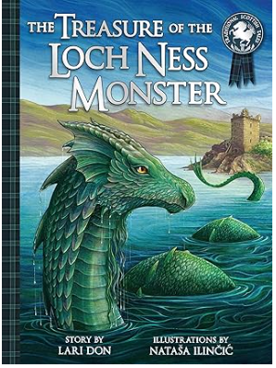 | 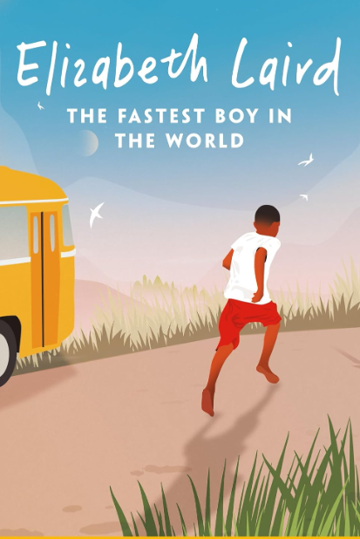  Romans:  Non-Chronological Report | 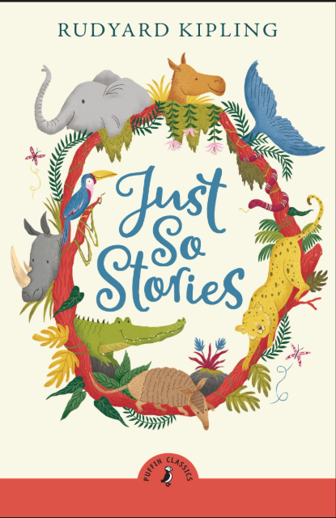  Poem with a structure  Persuasive letters | Passport to Europe  The Dancing Bear  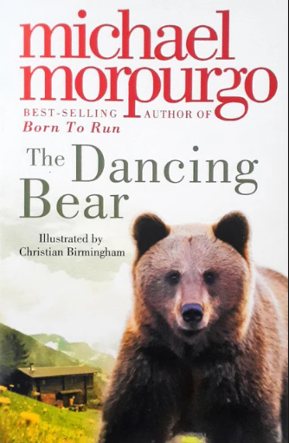  Persuasive Leaflets (Italy) |   Debate (Reading Week) | Poetry: McCavity  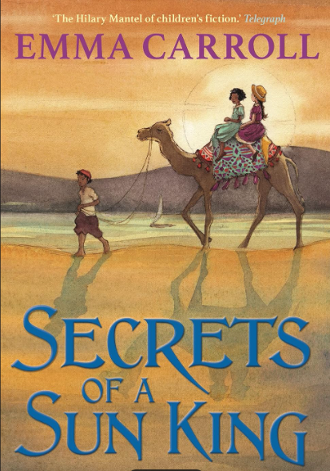
Maths | Year 3  Place value, addition and subtraction  Length and perimeter  Statistics  Addition and subtraction  Year 4  Place value, addition and subtraction  Length and perimeter  Statistics  Addition and subtraction | Year 3  Multiplication tables 3 x and 4x  Multiplication  Division  Time  3D shape  Assess and review  Year 4  Multiplication  Division  Time  3D shape  Assess and review | Year 3  Place value, addition and subtraction  Multiplication  Division  Volume, mass and capacity  Year 4  Place Value  Multiplication  Division  Addition and subtraction  Fractions | Year 3  2D shape  Addition, Subtraction and statistics  Fractions  Position and direction  time Assess and review  Year 4  Addition, subtraction and money  2D shape and sorting  Position and direction  Area  Statistics  Measures  Assess and review | Year 3  Addition and Subtraction  Multiplication and division  2D shape  Decimal place value  3D shape  Year 4  Place value  Addition and subtraction  Multiplication, division and measures  Area | Year 3  Place value  Calculation  Fraction  Statistics  Time  Assess and review  Year 4  Fractions, 2D and 3D shape  Statistics  Place value  Assess and review
Creative Topic Title | Heavenly Habitats  Science driven | Rockin’ Romans  History Driven | Terrible Tudors  History Driven | Avventure Italiane  Geography Driven | Forces in Nature  Science/ Geography driver | Awfully Awesome Egyptians  History Driver
Science | Living things and their habitats in the UK |  | Light and electricity |  | Forces and magnets | States of matter
Geography | Field work |  |  | Focus Continent: Europe  Focus Country Study: Italy | Extreme Earth:  Volcanoes
History |  | Roman Britain | Tudor Britain |  |  | Ancient Egyptians
Computing | Project Evolve – Copyright and Ownership | Interactive Comics (Presentation & Media)  iPads | Project Evolve: Online Reputation | Interactive Story Graphs (Data Handling & Simulations)  Laptops | Project Evolve: Online Bulling | Animations in Scratch (Programming & Networks)  Laptops
Art | Beth Collins  Printing/3D (Nature) Linked to Science – Living things and their habitats |  |  | Amedeo Modigliami  Linked to Geography - Italy |  | Digital Art linked to Egyptians
DT |  | Roman Food |  | Textiles |  | Electrical Systems
French | At home  Pets | At the zoo | Age, date and birthday  Colours | Fruit and the supermarket | France and culture  Numbers 1 – 50  The weather | Sports and hobbies  Musical instruments
PE | Lesson 1: FMS assessment  Invasion games: Rugby  Lesson2: Gymnastics year 3/4 activities 1 | Lesson 1: Invasion games: Netball  Lesson 2: Dance | Lesson 1: Net and Wall Core task 1  Lesson 2: Gymnastics Year 3/4 activities 2 | Lesson 1: OAA: the great outdoors  Swimming?  Lesson2: Target games: Dodgeball | Lesson 1: Target games: Boccia  Swimming?  Lesson 2: Dance | Lesson 1: Striking and fielding: Cricket  Swimming?  Lesson 2: Athletics
Music | Glockenspiel 2 | Rocking Romans – BBC  + composition (Glock) | Mama Mia | Stop! | Bringing Us Together | PERFORMANCE  Nice Weather for Ducks
PSHE | Relationships  Families and Close Positive Relationships | Relationships  Respecting Self and Others | Health & Wellbeing  Healthy Lifestyles (Physical Wellbeing) |  | Living in the Wider World  Money
RE  Key question  (must be taught) | Hinduism  What might a Hindu learn from celebrating Diwali?  Diwali- 31/10 to 31/11 | God  How and why might Christians use the Bible? | Jesus  Is sacrifice an important part of religious life? | Islam  Why do Muslims fast during Ramadan?  Ramadan- 11th March to 10th April | Church  What does “Love your neighbour” really mean? | Sikhism  How do Sikhs express their beliefs and values?
Possible Enrichment/Enhancements
Enrichment and Enhancement | Highgate Woods | Church/St Cuthberts | Class Trip: Hadrian’s Wall
Outdoor Learning/  Forest school | 3D ART – habitats | Roman Mud forts/shelters | War of the roses  Tudor games – jousting, hunting, bowls | Outdoor cooking linked to Italy  Painting – sunflowers | Erupting volcanoes

