 | Autumn Term 2024 |  | Spring Term 2025 |  | Summer Term 2025
 | Autumn A | Autumn B | Spring A | Spring B | Summer A | Summer B
English  Books | LPDS – Bridging Unit  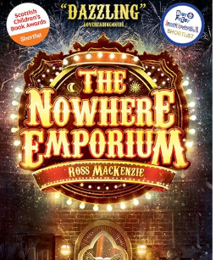  Information Text Hybrid – Discussion text – Circus/Magic | Letters from the Light House  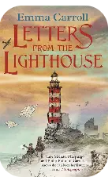  Hybrid Information Booklet | (Amazon Adventure)  Journey to the River Sea  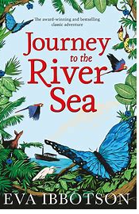  Debate: Palm Oil/Climate Change/Hunting/  Deforestation | Survival  Running Wild  Reading for Pleasure  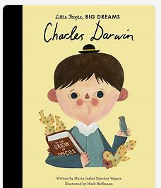  Biographies  Charles Darwin and one other. | The Lion and Albert -Push Pack   | Oh I do Like to be beside the seaside  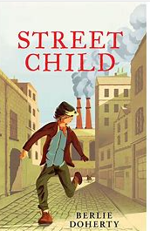  Street Child
Maths | Year 5  Place Value  Addition and Subtraction  Statistics  Geometry (angles)  Geometry and Measures  Year 6  Number, place value and decimals  Addition and subtraction  Multiplication  Division | Year 5  Multiplication and division  Fractions  Multiplication and Area  Time  Assess and Review  Year 6  Fractions, decimals and percentages  Algebra and sequencing  Geometry and area  Statistics  Assess and Review | Year 5  Place Value and Negative Numbers  Addition and subtraction  Multiplication and division  Measure (Length mass and capacity)  Geometry  Year 6  Place value, negative numbers and number sequences  Co-ordinates and geometry  Calculations  Fractions | Year 5  Fractions  Geometry (Shape)  Measurement (Volume)  Statistics  Problem solving including bar model  Assess and Review  Year 6  Ratio and proportion  Statistics  2d and 3D shapes  Measurement  Algebra  Assess and Review | Year 5  Place Value  Measurement and statistics  Geometry  Addition and Subtraction  Multiplication  Year 6  Revision  Test Week  Applied Maths | Year 5  Divisions  Fractions  Percentages  Statistics  Measurement  Assess and Review  Year 6  Addition and subtraction  Multiplication  Division  Applied Maths  Assess and Review
Creative Topic Title | Humanities  Geography – war time countries  History theme – WW2 |  | STEM theme – Evolution/ Charles Darwin with links to Brazil |  | Creative  Art – LS Lowry  Music – Y6 show
Science | Electricity – link to black out shelters |  | Evolution | Animals including humans (link to evolution) | Properties
Geography | Field Work/Weather Changes |  | South America/ Brazil |  | Types of Settlements/Fieldwork (Docks)
History |  | WW2 |  | Preston through the ages (docks) (make links to changes with Brazil) | Children in Victorian Britain
Computing | Project Evolve – Online Reputation | Animated Scenes (Creative Media & Asset Production)  iPads | Project Evolve – Managing online information | Data Handling in Google Sheets (Data Science & Analytics)  Laptops | Project Evolve – Health, Well-being and Lifestyle | Micro-bit Physical Computing (Programming & Hardware)  Laptops
Art |  | Henry Moore – 3D clay (WW2) | Romero Britto (digital art) |  | LS Lowry – painting
DT | Electricity |  |  | Food and nutrition – cooking (Brazil) |  | Textiles – tapestry
French | Emotions | Colours, clothes and shopping | Physical description | Places and descriptions | Pen Pals | Time
PE | Lesson 1: WW2 dance/OAA  Lesson2: Rugby | Lesson 1: WW2 dance/OAA  Lesson 2: Netball | Lesson 1: Dance  Lesson 2: Tennis | Lesson 1: OAA  Lesson2: Athletics | Lesson 1: Gymnastics  Lesson 2: Cricket | Lesson 1: Gymnastics  Lesson 2: Rounders
Music | Fundamentals and recorder 2 | WW2 music | Fresh Prince of Bel Air | Classroom Jazz 2/ Garage band | Happy | Farewell show
PSHE | Relationships – Families and close positive relationships |  | Health and wellbeing – Mental health | Health and wellbeing – Ourselves, growing and changing (Y6 puberty) | Wider World – Digital resilience | Wider world – money (and Y7 transition)
RE  Key question  (must be taught) | Hinduism – Is there one journey or many? | Church – If life is like a journey, what’s the destination? | How do Christians mark the “turning points” on the journey of life? | Jesus - Why do Christians believe Good Friday is “good”? | Islam - What is Hajj and why is it important to Muslims? | Buddhism - What do we mean by a  “good life”?
Possible Enrichment/Enhancements
Enrichment and Enhancement | Beacon Fell orienteering? | Air raid shelter trip – Stockport  Make an Anderson shelter (mod rock)  Trip to sculpture park | Mr Men characters – evolving into different shapes | Parents come to Brazilian restaurant (end)  Brazilian drumming (with Julie M) | Class Trip: Imperial War Museum and Science and Industry Museum. | Trip to the docks - walk (start)  Y6 end of year trip
Outdoor Learning/  Forest school |  | Make mod rock shelters outside |  | Outdoor cooking |  | Team building

